Amine functionalized MCM-41 as a green, efficient, and heterogeneous catalyst for the regioselective synthesis of 5-aryl-2-oxazolidinones from CO₂ and aziridines
Deepak B. Naleª, Surjyakanta Rana^{b}, Kulamani Parida^{b} and Bhalchandra M. Bhanage^{a,}*
Department of Chemistry, Institute of Chemical Technology, Mumbai- 400019

Covalently linked amine functionalized MCM-41 catalysts were investigated as an efficient, heterogeneous and recyclable catalyst for the coupling of carbon dioxide (CO₂) and aziridines providing high conversion with excellent regioselectivity towards 5-aryl-2-oxazolidinones under mild and solvent free conditions. The effect of various reaction parameters, such as temperature, time, and CO₂ pressure for the synthesis of 5-aryl-2-oxazolidinones using amine functionalized MCM-41 catalyst was investigated. The optimized protocol was applied to a wide variety of 1-alkyl-2-arylaziridines producing the corresponding 5-aryl-2-oxazolidinones with good yield and excellent regioselectivity. Amine functionalized MCM-41 catalysts were characterized by FT-IR, TG/DTA, high and low angle XRD, and solid state ²⁹Si CPMAS NMR analysis. Furthermore, the catalyst was effectively recycled for five consecutive cycles without any significant loss in its catalytic activity and selectivity under the described reaction conditions. Readily available reagents, mild reaction conditions and effective catalyst recyclability make this protocol simple, convenient, practical and environmentally friendly.

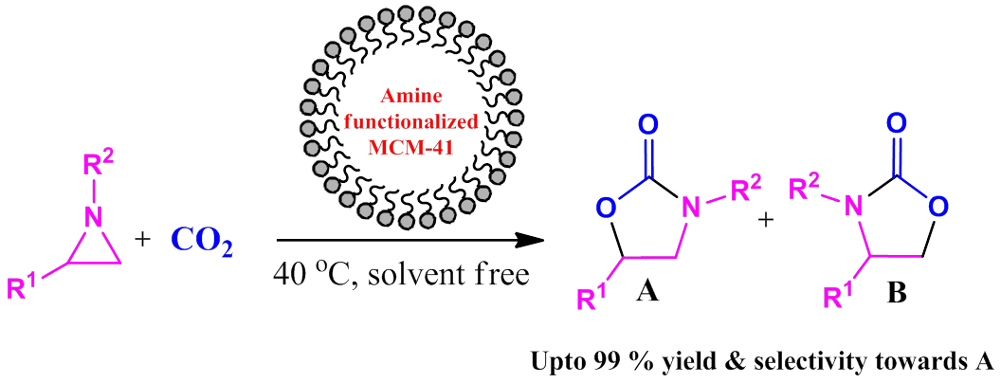

Thrust Area: Green Chemistry
Poster Presentation

