EFFECT OF SILVER NITRATE AND NICKEL CHLORIDE ON SHOOT MORPHOGENESIS IN DIANTHUS

Submitted
in partial fulfillment of the requirement of the degree of
Master of Philosophy
in the Faculty of
Life Sciences


THE IIS UNIVERSITY, JAIPUR

BY:
VASUNDHRA SINGH

UNDER THE SUPERVISION OF:
DR. ANUJA JOSHI

DEPARTMENT OF BOTANY
THE IIS UNIVERSITY
(2011-2012)

ACKNOWLEDGEMENT

I express my deep sense of gratitude to Dr. Ashok GUPTA, Director, The IIS University and Dr. rakhi GUPTA, Principal, The IIS University who provided me an excellent and healthy environment as well as well equipped facilities.

With humble respect I would like to give my sincere thanks to Professor pradeep bhatnagar, Dean, Department of Life Sciences, The IIS University, for acting as the constant pillar of support and guidance throughout my endeavor.

With heartfelt gratitude and immense pleasure I acknowledge my guide, DR. ANUJA JOSHI, Assistant Professor, Department of Botany, The IIS University, without whose supervision and guidance this work would not have been a success. I have had the advantage of her critical advice from her profound knowledge in the subject.

VASUNDHRA SINGH
M. Phil. Life Science

CONTENTS

INTRODUCTION………………………………………………….1-4

REVIEW OF LITERATURE…………………………………… . 5-10

MATERIALS AND METHODS………………………………… 11-17

Plant Material
Seed Viability Test
Explants taken from aseptically grown seedlings
Equipments and apparatuses
Sterilization and preparation of explants
Basal medium preparation
Aseptic manipulation
Induction of shoot buds
Subculture Procedure
Rooting of explants
Protocol for Dianthus culture
Incubation
Observation
Statistical Analysis

OBSERVATIONS AND RESULTS………………………..........18-27

Seed Viability Test
Seed Germination
Explant Culture
Effect of cytokinin and auxin
Effect of varying concentration of heavy metals

DISCUSSION……………………….…………………………….28-30

SUMMARY……………………………………………………….31-32

REFERENCES…………………………………………………….33-40

ABBREVIATIONS

BAP : 6-Benzyl Aminopurine
NAA : α-Naphthalene Acetic Acid
cm : Centimeter
2, 4-D : 2, 4- dichlorophenoxyacetic acid
DW : Distilled water
Fig. : Figure
gm. : gram
mg/l : milligram per liter
ml : milliliter
mm : millimeter
MS : Murashige and Skoog (1962) medium
S. D. : Standard Deviation
UV : Ultraviolet
W : Watt
w/v : Weight by volume
µmol : Micromole

INTRODUCTION

Dianthus is one of the world’s most popular, economic and important cut flowers due to its excellent keeping quality, wide range of forms, ability to withstand long distance transportation and remarkable ability to rehydrate after continuous shipping, perpetual flowering and presence of new single- and multi-colour cultivars and is native of the Mediterranean region.
It belongs to family Caryophyllaceae. The Caryophyllaceae, commonly called the pink family or carnation family, is a family of flowering plants. It is a large family, with 88 genera and some 2,000 species. This cosmopolitan family consists of mostly herbaceous plants and is best represented in temperate climates, with a few species growing on tropical mountains. Some of the more commonly known members include pinks and carnations (Dianthus), and Firepink and Campions (Lychnis and Silene). Many species are grown as ornamental plants, and some species are widespread weeds. Most species grow in the Mediterranean and bordering regions of Europe and Asia.

CLASSIFICATION
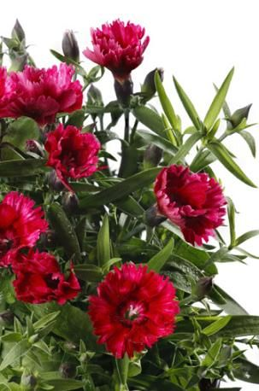
Kingdom : Vegetabile
Sub-Kingdom : Angiospermae
Division : Dicotyledonae
Class : Polypetalae
Order : Caryophyllinae
Family : Caryophyllaceae
Genus : Dianthus

The genus Dianthus consists of more than 300 species including the ornamentals such as Carnations (D. caryophyllus L.), Pinks (D. chinensis) and Sweet Williams (D. barbatus). D. caryophyllus is a top-selling ornamental crop worldwide. D. chinensis is short-lived, perennial garden plants, native to China and northern parts of India, blooming in several colours. Certain varieties of pinks have a strong clove scent, which has made them popular in perfumes for more than 2,000 years. It has a wide range of medicinal uses as well. D. barbatus (biennial carnation) is native to the mountains of southern Europe from the Pyrenees east to the Carpathians and the Balkans, with a variety disjunct in north-eastern China, Korea, and south-easternmost Russia. It is traditional used in landscaping and cut flowers. Dianthus is also used for culinary purpose. Crystallized petals are used for decorating cakes, while fresh petals can be used in salads, pies, and sandwiches. Petal bases are removed before using it for culinary purposes because of the better taste.
Dianthus is an herbaceous perennial plant growing upto 80 cm tall. The leaves are glaucous greyish green to blue-green, slender and up to 15 cm long. The flowers are produced singly or in group of five together in a cyme, and sweetly scented. The leaves are linear, lance-shaped and blue-grey or grey-green in colour, with a waxy texture. The fruit is non-fleshy. It is usually a capsule, less frequently a small nut. The original natural flower colour is bright pinkish-purple, but cultivars of other colours, including red, white, yellow and green have been developed through breeding and planted in well-drained soil in a sunny location.
Dianthus cultivation is associated with various problems .The seeds show the high level of heterogeneity in the seed population which acts as a constraint to propagation of agronomic traits and for commercial seed production. Carnation breeders constantly seek new varieties with improved horticultural traits such as disease and pest resistance and long vase-life. The traditional breeding programs for selection of superior clones are tedious and utilizing huge amount of seed results in wastage of the seeds significantly. In vitro technology has often been used as a promising avenue to plant improvement for research and practical applications. Plant tissue culture, is of great value, particularly as an alternative to conventional breeding and propagation procedures.

PLANT TISSUE CULTURE MEDIUM
Growth and morphogenesis of plant tissue under in vitro conditions are largely governed by the composition of the culture medium. Various culture media formulation proposed consist of several basal components which include mineral nutrients, vitamins, amino acids, growth regulators, sugars, agar and water in various concentrations. Mineral nutrients are the building blocks for the synthesis of organic molecules and also act as catalysts in enzyme reactions. The ions of the dissolved salts also play important role as counter-ion in the transport of ionized molecules by the plant, in the osmotic regulation and in maintaining the electrochemical potential of the plant. The mineral salts in media can be broadly classified into two groups: microelements and macroelements. Microelements including Fe, Cu, Zn, Co, Mo, B, Cl and I are required in relatively low concentration but their deficiency can have catastrophic effects. Mg, Ca, S, P, K and N are considered as macroelements since they are required in high concentration. Vitamins, amino acids, growth regulators and sugars act as organic supplements in the medium. Agar and Phytagel are added as gelling agents. All these components fulfill the one or more requirements of plant under in vitro conditions.
The formulation of the mineral components of the media has been an empirical process since the beginning of tissue culture. Knop (1865) proposed a salt solution which formed the basis for culture medium. Kotte (1922) cultured small root tips of pea and maize which could not survive indefinitely on medium proposed by him. White (1934), Gautheret (1939) , Hildebrandt et al (1946) did remarkable work and provided the necessary impetus on developing plant cell and tissue culture medium.

A landmark in media formulation was put forward by Murashige and Skoog (1962) by the development of MS medium. They were able to achieve several fold increase in yield of tobacco callus cultures by addition of leaf extract to the modified White’s medium. The concentration of all ingredients in MS medium was increased as compared to the White’s medium. Scanning of the plant tissue culture literature leads to the conclusion that MS is the most frequently used medium. Many different media are basically MS with minor changes.
The MS basal medium proposed by Murashige and Skoog (1962) was originally developed for the culture of tobacco pith callus. It may not be optimum for the culture of other plant species, as different plant species have different nutrient requirement during successive stages of growth and development. Nutrient at particular level has the potential to partially substitute the requirement of plant growth regulators in the medium (Preece, 1995). An understanding of optimal nutrient concentration could lead to increased growth and could evoke morphogenesis in vitro more efficiently.
Several heavy metals also play important role in the regeneration of plant as microelements. Sliver as silver nitrate and cobalt as cobalt chloride act as ethylene inhibitor. Nickel as nickel chloride proved to be effective in stimulating morphogenesis, shoot regeneration and callus induction. Sliver nitrate (AgNO₃) has proved to be a very potent inhibitor of ethylene action and widely used in plant tissue culture. AgNO₃ has been employed in plant tissue culture studies for inhibiting ethylene action because of its water solubility and lack of phytotoxicity at effective concentration (Beyer, 1976).

Considering these facts, the present work has been taken up with the following objectives:
- Standardization of reproducible regeneration protocol for Dianthus.
- To study the effects of heavy metals (sliver and nickel) on shoots morphogenesis.
- Acclimatization and hardening of regeneration plantlets.

REVIEWOF LITERATURE

Carnation is one of the most important cut flower crops grown worldwide on a commercial scale, and ranks the top among cut flowers (Duhoky et al, 2009). High commercial value and consumer demand for new varieties act as the driving force for carnation breeding (Moyal-Ben Zvi and Vainstein, 2007). This review present a consolidated account of micropropagation and effect of heavy metals on shoot morphogenesis.
Plant tissue culture is the science of growing plant cells, tissues or organs isolated from the mother plant on artificial media. One of the most exciting and important aspects of in vitro cell and tissue culture is the capability to regenerate and propagate plants from cultured cells and tissues. A wide range of plants has now been regenerated through this tissue culture technique has been found particularly useful for propagation of plant species whose production is less as compared to its rate of consumption, so that demand for the same could be meet.
The development of a reliable and efficient in vitro regeneration system for a particular species becomes essential to facilitate genetic transformation and a future aim of genetic modification (Hansen and Wright, 1999; Tawfik and Noga, 2001 & 2002). Although it is now possible to dispense with micropropagation for genetic transformation, such methods are currently limited to a small number of plant species. However, micropropagation which tends to introduce certain random genetic changes resulting from somaclonal variation is still sought after. Somaclonal variation tends to negatively affect transgene expression (Birch, 1997; Matzke and Matzke, 1998) minimize the organogenetic potential of the plant and is often accompanied by hyperhydricity (Cassells and Curry, 2001).
Moreover, a suboptimal in vitro environment may exacerbate the occurrence of somaclonal variants and consequently, hamper further microplant development, such as rooting and acclimatization (Cassells and Curry, 2001).Subsequently, omission of a callus stage as a precursor for organogenesis is the preferred strategy for the avoidance of somaclonal variation (Skirvin et al., 1994; Cassells and Curry, 2001; Susek et al., 2002).

Explant selection is a very important factor affecting the morphogenic potential of plant system. Adventitious shoot regeneration in carnation has been reported from various explants such as shoot tips (Baker and Philips, 1962; Earle and Langhans, 1975; Jethwani et al., 1994) hypocotyls (Petru and Landa, 1974), leaf (Van Altvorst et al., 1992, Kantia and Kothari, 2002), stem segments (Van Altvorst and Koehorst, 1995), axillary buds (Van Altvorst and Koehorst, 1995; Ghosh, 1987), petals (Leshem et al., 1988; Nugent et al., 1991; Van Altvorst et al., 1992; Messeguer et al., 1993; Fisher et al., 1993; Sankhla et al., 1994; Nakano et al., 1994), anthers (Villalobos, 1981), cotyledons (Nontaswatsri and Fukai, 2005) and ovules (Demmink et al., 1987).
Messeguer et al., (1992) reportated adventitious shoot regeneration in carnation (Dianthus caryophyllus L.) using leaves, basal segments of flower and petals from greenhouse grown Dianthus as explant .Explants were cultured on MS medium containing various concentrations of 6-benzylaminopurine (BA) and α-naphthalene acetic acid (NAA). Petals and floral segments exhibited a high morphogenetic potential when cultured on various growth regulator. Basal segments were the only part of the leaf that generated shoots when cultured on medium supplemented with 0.01 mg/ l NAA and l mg/ l BA. Dark conditions and an agar concentration of 5.5 g/ l significantly improved the percentage of regenerating leaves and the number of shoots per leaf explant. These shoots were normal, with a vegetative shape and could easily be transferred to greenhouse conditions.
Van Altvorst et al., (1992) reported adventitious shoot formation from in vitro leaf explants of Dianthus caryophyllus. Leaves were cultured on MS medium with 0.3 mg/l BA and 0.3 mg/l NAA. After 2 weeks, adventitious shoots developed at the bases of the explants. Both BA and NAA in the range 0.1–0.9 mg/l affected the average numbers of shoots per regenerating explant, but not the regeneration percentage. The highest number of adventitious shoots was obtained on medium containing 0.9 mg/l BA and 0.3 mg/l NAA. Adventitious shoot regeneration was compared among leaf, stem and petal explants of D.caryophyllus L. cv. Scania on MS medium containing different concentrations of 6-BA and NAA by Nakano et al., (1993).
High frequency regeneration was obtained only from petal explants on the media containing 5 to 10 M BA with or without 5 M NAA. Among the cytokinins tested, N-2-chloro-4-pyridyl-N'-phenylurea and N-1, 2, 3-thiadiazol-5-yl-N'-N'-phenylurea were more effective than BA, kinetin, N6-2-isopentenyl adenine and zeatin on regeneration from petal explants.Miller et al., (1991) reported shoot regeneration in Carnation (D. caryophyllus) from axillary bud explants (excised from leaf axils of the young shoots), leaf and stem. The explants cultured on a MS medium supplemented with 15µM BA and 0-5 µM NAA and solidified with Gelrite.The best response in terms of shoot induction was obtained from the axillary bud explants. Shoots were transfer onto a medium solidified with agar to minimize visible signs of vitrification. Miller et al., (1992) studied the shoot morphogenesis from fragmented flower buds, petals explants were cultured on MS medium supplemented with 4-8 µM NAA and 4-8 µM BAP. The yield of shoots from a single flower bud was high, ranging between 70 and 275, for the11 different cultivars tested.

Salehi (2005) reported the shoot regeneration of carnation (D. caryophyllus L.) using shoot tip as explant when cultured on MS fortified with 3 mg/l kinetin and 0.5 mg/l NAA or 1 mg/l BA and 1 mg/l NAA. Pareek et al., (2009) reported the micropropogation of D. caryophyllus, D. barbatus and D. chinensis using shoot tip and nodes as explant. They were cultured on MS medium supplemented with NAA and BAP. The best response in terms of shoot multiplication was obtained on MS medium supplemented with NAA (0.5mg/l) and BAP (1mg/l).

Danial et al., (2009) reported in vitro propagation of carnation (D. caryophllus L) by using shoot apical meristems as explant cultured on MS medium supplement with BAP and kinetin (0.0-2.0 mg/l).The results revealed that maximum multiplication of shoot tips occurred in the presence of 1.0 mg/l of either BAP or Kinetin. Duhoky et al., (2008) reported that in vitro micropropagation of carnation, Shoot tip and single node explants were obtained from actively growing healthy shoots of two cultivars of carnation D. caryophyllus L.: early growth cultivar (E-cultivar) and late growth (L-cultivar) cultured on MS media supplemented with different concentrations of cytokinins and auxins. The highest response percentage was (71.84%) noticed by culturing the explants of E-cultivar. The best results in initiation stage were occurred when the explants of E-cultivar cultured on MS medium supplemented with a high concentration of BA and low concentration of IAA. The highest multiplication rate (2.563 shoots/explant) were obtained by culturing the explants of L-cultivar on MS medium supplemented with 2.0 mg/ l BA+ 0.1 mg/ l IAA, but the highest growth rate were occurred in shoots of L cultivar which was cultured on MS medium contained low concentration of BA or without it, and low concentration of IAA. All the plantlets were rooted easily in multiplication media.

Silver ions in the form of nitrate, such as AgNO₃, play a major role in influencing somatic embryogenesis, shoot formation and efficient root formation which are the prerequisites for successful genetic transformation (Bais et al., 1999; Bais et al., 2000a; Bais et al., 2000b; Bais et al., 2001a; Bais et al., 2001b; Bais et al., 2001c). Silver ions are also employed in the form of silver thiosulphate in several tissue culture studies (Eapen and George, 1997).Ethylene is recognized as a ubiquitous plant hormone (Lieberman, 1979; Yang, 1985), which influences growth and development of plants (Abeles, 1973; Yang and Hoffman, 1984; Mattoo and Suttle, 1991). In vitro studies have indicated that ethylene can affect callus growth, shoot regeneration and somatic embryogenesis in vitro (Purnhauser et al., 1987; Songstad et al., 1988; Roustan et al., 1989; Roustan et al., 1990; Biddington, 1992; Pua and Chi, 1993). Thus, by regulating the production or action of ethylene, the growth and development of some tissue cultures can be controlled to a certain extent (Beyer, 1976c; Davies, 1987; Purnhauser et al., 1987; Songstad et al., 1988; Chi and Pua, 1989; Bais et al., 2000a; Giridhar et al., 2003).

AgNO3 has been known to inhibit ethylene action (Beyer, 1976a) and cobaltous ions are known to inhibit ethylene synthesis (Lau and Yang, 1976).Increased shoot and root induction using high AgNO₃ concentrations were reported for Dianthus (Gutiérrez-Miceli et al., 2010), Triticum and Nicotiana (Purnhauser et al., 1987) and Brassica napus (De Block et al., 1989). Gutiérrez-Miceli et al., (2010) reported effect of AgNO₃ in stimulating morphogenesis in callus redifferentiation in D. caryophyllus by using meristems as explant. Callus clusters were cultured on MS medium containing kinetin (0, 33, and 66 μM), NAA (0, 7.95, and 15.9 μM) and AgNO₃ (0, 23.54 and 47.08 μM) for shoot and root induction.

A maximum of 78% calluses with shoots was obtained on medium supplemented with NAA (15.9 μM) and AgNO₃ (47.08 μM). The influence of silver nitrate (AgNO₃) and cobalt chloride (CoCl₂) on shoot multiplication and in vitro flowering in Capsicum frutescens was investigated by Sharma et al., (2008). Both AgNO₃ and CoCl₂ at a concentration of 30 μM resulted in the maximum tissue response in terms of shoot length and number of shoots after 45 days culturing on MS medium. The morphogenetic response of Brassica campestris genotype R500 was reported by Palmer (1992) medium containing NAA, BAP and AgNO₃ significantly enhanced both percentage shoot regeneration and number of shoots per cotyledon explant.
The impact of Ni toxicity on the physiology of plants depends on the type of plant species, growth stage, cultivation conditions, Ni concentration and exposure time (Krupa et al., 1993; Xylander and Braune 1994; Marschner 1995; Kabata-Pendias and Pendias 2001; Assuncao et al. 2003) in the soil. The toxic effects of higher concentration of Ni are observed at multiple levels, these include inhibition of mitotic activities (Rao and Sresty 2000), reduction in plant growth (Molas 2002), plant water relation and photosynthesis (Chen et al.,, 2009), inhibition of enzymatic activities as well as nitrogen metabolism (Gajewska et al., 2009), interference with the uptake of other essential metal ions (Chen et al., 2009), induction of oxidative stress (Chen et al., 2009). All of these alter physiological processes culminating ultimately in reduced fruit yield and quality (Gajewska et al., 2006). Germination of seeds and seedling growth of Brassica juncea were significantly reduced by Ni (25, 50, 100 mg dm-3) treatment (Sharma et al. 2008).

Moreover, the roots of Nicotiana tabacum became dark brown within 7–10 days of exposure to Ni (0.43 mM) and the growth of plants was severely inhibited (Boominathan and Doran 2002) by Ni and other heavy metals results from general metabolic disorders and immediate inhibition of cell division. However, it is not clear whether Ni enters cell nuclei at high concentrations and if it does, how important is immediate interference of Ni with DNA and nuclear proteins. (Yusuf et al., 2011)

Hyperhydricity which is of common occurrence in plant tissue culture is much more severe in Caryophyllaceae (Mii et al., 1990). In Dianthus caryophyllus it has been reported that the hyperhydric shoots showed reduced apical dominance, hypertrophy and defective cell walls (Werker and Leshem, 1987). Hyperhydricity during micropropagation of carnation was reduced to 0% by media modification. Increased concentration of iron and/or magnesium reduced hyperhydricity with 0.7-0.8% agar and increased shoot multiplication (Yadav et al., 2003).Vitrified shoots regenerated from carnation petals D. caryophyllus were recovered by culturing them in a medium containing 3.0 g/l bactopeptone reported by Sato et al., (1993).

Jain et al., (2001) reported regeneration of de novo shoots from leaf derived callus of carnation using induction medium contained 2, 4-D and BAP. Shoot buds were formed when the callus was further subculture on 2, 4-D- and BAP-containing medium, or MS medium without any growth regulators. The shoots so formed were hyperhydric, bushy in appearance with reduced stem length and watery leaves. The normal conformation of shoots was restored by culturing the hyperhydric shoots onto medium supplemented with GA3 and bactopeptone. The recovered shoots were rooted on MS medium added with NAA (1 mg/l) or IBA (2 mg/l).

Adventitious shoot regeneration was compared among leaf, stem and petal explants of carnation
(Dianthus on MS medium containing different concentrations of 6

MATERIALS AND METHODS

PLANT MATERIAL
Dianthus, an important horticultural plant has been taken up for the present study. The seeds of Dianthus (L.) were procured from Namdhari Seed Agency, Bengaluru (India).

SEED VIABILITY TEST
Dormancy of seeds is a major factor affecting its germination. Hence the seeds obtained were subjected to a seed viability test to check the percentage of viable seed in the provided seed-lot. 10 seeds were placed on a wet filter paper which was placed over a thin wet layer of cotton in a Petri plate. This set up was kept in a dark chamber for 48 hours. The seed viability percentage was calculated by the formula:
Seed Viability Percentage = No. of seeds germinated / Total no. of seeds kept for germination × 100

EXPLANTS TAKEN FROM ASEPTICALLY GROWN SEEDLINGS

Various explants from aseptically germinated seeds were taken for the present study.
Explants to be taken from aseptically grown seedlings:
- Hypocotyl (0.5-0.7 cm)
- Cotyledon (whole expanded lamina along with petiole 1-2 mm)
- Cotyledonary node with shoot tip and part of hypocotyls (1-2 mm) after separating both the cotyledons

Explants to be taken from aseptically grown mature plants:

- Leaf
- Nodes
- Internodes
- Shoot tips

EQUIPMENTS AND APPARATUS

The following equipments and apparatus were used during the study.
- Glassware (Borosil)
- Erlenmeyer conical flasks : 100-250 ml capacity
1000 ml capacity
- Test tubes : 25 × 150 mm
- Beakers : 100-1000 ml capacity
- Measuring Cylinders : 10-1000ml capacity
- Pipettes : 0.1-10 ml capacity
- Petri plates : 100 × 50 mm diameter
- Reagent bottles : 100-150 ml capacity
- Electronic balance : Shimadzu, 0.001-310 g weighing capacity
- Autoclave : Life, India
- Laminar Air Flow cabinet : Deepak Meditech Pvt. Ltd., India
- pH meter : Elico, India
- Refrigerator : Samsung
- Miscellaneous : Forceps(different sizes), scalpels, spatula,
spirit lamp and aluminium foil.

STERILIZATION AND PREPARATION OF EXPLANTS
The seeds were washed with 20% (v/v) Extran followed by four rinses in distilled water. Seeds were surface sterilized in 0.1% (w/v) mercuric chloride (HgCl₂) aqueous solution for 3 minutes with continuous stirring and washed thoroughly with three changes of sterile distilled water to remove any traces of HgCl₂ in the Laminar Air Flow cabinet. The seeds were then germinated on half strength MS media with 3% (w/v) sucrose and solidified with 0.8% (w/v) agar, pH adjusted to 5.8. Explants as stated above were excised from respective donor plants. These explants were inoculated on MS medium supplemented with varying concentrations of cytokinins added singly or in combination with different auxins to standardize the protocol for Dianthus micropropagation.

BASAL MEDIUM PREPARATION
Basal medium used in this study was MS (Murashige and Skoog, 1962) medium. The constituents and composition of this medium is given in Table 1. Stock solutions of various organic and inorganic nutrients were prepared at various concentrations by dissolving their weighed amounts in distilled water. Each component was added according to the list of ingredients. Each ingredient was completely dissolved before adding the next.
The stock solutions of growth regulators were also prepared. For preparing the stock solutions of the growth regulators; auxin was first dissolved in few drops of absolute alcohol and the final volume was made up by adding distilled water (20 mg growth substance was dissolved in 100 ml distilled water).These stock solutions were stored in different reagent bottles and placed in the refrigerator. They were used within a week of their preparation.
The medium was prepared in 1000 ml measuring cylinder containing distilled water and all the mineral nutrients and sugar (dissolved in small volume of distilled water) was added. The final volume was made up by adding distilled water. The medium was poured in different beakers and growth regulators added and solidified with agar (0.8%). Similarly medium were prepared which contain induction medium with the different concentration of AgNO₃ and NiCl₂ were added exogenously into separate beakers .The pH of the medium was adjusted to 5.8 by adding 0.1N HCl and 1N NaOH. The medium was finally dispensed into Erlenmeyer 100 ml flasks or culture tubes. Each flask contained approximately 30 ml of medium and the culture tubes contained 20 ml medium. They were marked for their medium composition. The mouth of the culture vessels was plugged with non-absorbent cotton and autoclaved at 121⁰C and 1.06-kg/cm² (105 kPa) pressure for 20 minutes.

ASEPTIC MANIPULATION
All precautions were taken for aseptic operation. All the culture vessels, measuring cylinders and bottles etc. were cleaned and rinsed with distilled water prior to use. The Petri plates and accessories were wrapped and autoclaved along with the medium. The measured volume of distilled water required for seed sterilization was also autoclaved in plugged conical flasks.
S. No. | Nutrient | Weight of nutrient in stock solution (mg) | Total volume of stock solution (ml) | Concentration of nutrient in stock solution as compared to the final medium | Volume of stock solution in 1 l of final medium (ml) | Final concentration in medium (mg/ l) | Final concentration in medium (mM)
A  B  C  D  E  F  G  H  I  J | NH₄NO₃  KNO₃  KH₂PO₄  KI  H₃BO₃  Na₂MoO₄.₂ H₂O  CoCl₂.6H₂0  CaCl₂.2H₂O  MgSO₄.7H₂O  MnSO₄.H₂0  ZnSO₄.7H₂O  CuSO₄.5H₂O  Fe₂(SO₄)₃.7H₂0  Na₂EDTA  Thiamine HCl  Pyridoxine HCl  Nicotinic Acid  Glycine  Myo-inositol | 33000  38000  6800  33.2  248  50  5  17600  14800  676  344  5  1114  1490  10  50  50  200  2000 | 400  400  200  200  200  200  200  200  100  200 | 50 X  50 X  200 X  1000 X  200 X  200 X  1000 X  200 X  1000 X  100 X | 20  20  5  1  5  5  1  5  1  10 | 1650  1900  170  0.83  6.2  0.25  0.025  440  370  16.9  8.6  0.025  27.8  37.3  0.1  0.5  0.5  2  100 | 20.6  18.8  1.25  5×10⁻³  0.1  1.03×10⁻³  0.11×10⁻³  2.99  1.5  0.1  29.9×10⁻³  0.1×10⁻³  0.1  0.1  0.3×10⁻³  2.43×10⁻³  4.06×10⁻³  26.64×10⁻³  0.56
Table 1: Composition of MS (Murashige and Skoog, 1962) basal medium
Sucrose : 3% (w/v)
Agar : 0.8-1% (w/v)
pH : 5.

The transfer chamber and culture room were also kept clean. In vitro transfer of explant was carried out in the Laminar Air Flow cabinet. The cabinet platform was swabbed with absolute alcohol along with the autoclaved flasks containing the medium and distilled water. Autoclaved and wrapped Petri plates, scalpels and forceps were placed in the cabinet. Spirit lamp, spirit column and cotton were also arranged inside the cabinet. The cabinet was then irradiated by UV rays for 35-40 minutes by UV tubes. After irradiation, the cabinet door was opened and in a continuous airflow from the Laminar HEPA filters the transfer process was carried out. Hands were properly wiped with spirit and the accessories were heated in the spirit lamp flame until red-hot. Special care was taken to avoid the tissue being touched by hot forceps/scalpels as it reduces viability of the tissue. All the glassware and instruments wiped with spirit were kept away from the burning spirit lamp. The rim of the Petri plates was also heated properly in the flame before inoculation.

INDUCTION OF SHOOT BUDS
Desired explants were cultured on MS medium supplement of various levels of plant growth regulators.

SUB-CULTURING PROCEDURE
The primary cultures were transferred to fresh medium after 4-5 weeks of culture incubation .The shoot bud induced from the explant were sectored into groups each having 3-4 of them. These clusters were then transferred on elongation medium cytokinins with various concentration of auxin.

ROOTING OF EXPLANTS
The elongated shoots were transferred on medium containing various concentrations of auxins for proper root system.

EFFECT OF HEAVY METALS

The explants (shoot tip and node) were excised from 20-25 days old aseptically grown seedling. The explants inoculated on MS medium supplemented with various concentrations of BAP and in combination with NAA. Effect of heavy metals (AgNO₃ and NiCl₂) was examined on shoot morphogenesis. The explants were cultured into two different types of media:
- The induction medium (0.5mg/l BAP and 0.5mg/l NAA)
- Induction medium with various concentration of heavy metals (AgNO₃ and NiCl₂)

INCUBATION

The culture flask was incubated in a growth chamber. The growth chamber was equipped with air-conditioner and temperature controller to maintain the temperature of the culture room at 26±1°C. A photoperiod of 16 hours light and 8 hours dark was maintained with the help of a timer and the light intensity was facilitated with fluorescent tubes.

OBSERVATION

The cultures were observed weekly for the formation of shoot or shoot initials. The origin of the shoot and the general state of the node and shoot tip explants was recorded. The numbers of shoot formed on each the node and shoot tip was counted. Additional records on the appearance of the shoot (colour and size) were taken.

STATISTICAL ANALYSIS

The observations recorded for the various experiments were subjected to following statistical analysis:

Average: The average (mean) was calculated by dividing the sum values of observations for a particular treatment by the total number of observations for that treatment:

_{AVERAGE = ∑n / N}

Where
∑n = summation of values of observations for a treatment
N = total number of observations for that treatment

Standard Deviation: This is a measure of dispersion which was calculated by squaring the deviation of each observation from the mean, adding the squares, dividing by the number of observation and extracting the square root according to:

σ = ±√ (∑ d²/ N)

Where
σ = standard deviation
∑ d² = summation of squares of deviation of each observation from the mean
N = number of observations

OBSERVATIONS AND RESULTS

SEED VIABILITY TEST
The viability percentage of D. caryophyllus, D. barbatus and D. chinensis was found to be 90%, 70% and 0% respectively (Fig. 2a). Hence seeds of D. caryophyllus were considered for further studies.

SEED GERMINATION
Seeds of D.caryophyllus were procured from Namdhari Seed Agency, Bengaluru. After proper sterilization, the seeds were inoculated aseptically on half strength MS media (Fig.2b). The first visible germination of seeds was observed after 4 days of inoculation. Seedling explants were taken from 12 days old seedlings and mature plant explants were taken from 25 days old seedlings.

EXPLANT CULTURE

Explants taken from aseptically grown seedlings
Effect of various concentrations of cytokinins (BAP) alone or in combination with auxins (NAA) was studied in hypocotyl, cotyledon and cotyledonary node.

EFFECTS OF CYTOKININ

Hypocotyl
Swelling was induced in hypocotyl when cultured on MS medium supplemented with BAP (0.2 -5 mg/l) after 2 week of the culture. The explant turned Yellowish on MS medium supplemented with BAP (0.2mg/l).Even higher levels of BAP in the medium could not evoke shoot regeneration. Hence they were discarded and were not used for further studies.

Cotyledon
Cotyledons were inoculated with adaxial surface in contact with medium. The explants were cultured on various concentration of BAP (0.2, 0.5, 1, 2, 3 and 5 mg/l). After incubation of 4 weeks cotyledon explants did not show any morphogenic response on medium supplemented with various concentration of BAP. Hence they were discarded and were not used as explant for further studies.

Cotyledonary node
Shoot regeneration was not achieved from Cotyledonary nodal explants when cultured on medium with various concentration of BAP. Hence they were not taken for further studies.

Explants taken from aseptically grown mature plants
Effect of various concentrations of cytokinins (BAP) alone or in combination with auxins (NAA) was studied in leaf, nodes and shoot tips.

EFFECTS OF CYTOKININS
Leaf
Leaf explants were inoculated with adaxial surface in contact with medium. Swelling of the explants was observed after 1week of culture on MS medium supplemented with various concentrations of BAP (0.2-5 mg/l).But the explants turned yellowish after incubation of 4 weeks and did not show any sign of shoot regeneration.

Nodes
Nodal explants were inoculated on MS medium supplemented with various concentration of BAP (0.2-5 mg/l). Formation of 2-3 shoots accompanied with little browing at the base of the explants was observed on BAP (0.2 mg/l).On increasing the level of BAP upto 0.5mg/l, increasing in the number of shoot buds was observed. A maximum of 4-5 shoot buds regenerated from the explant. On further raising the levels of BAP (1-5mg/l), shoots were formed but they were highly vitrified. The nodal explants showed better response than other explants in terms of quality and number of shoot bud induced per explant. Maximum number of shoots was regenerated on MS medium supplemented with 0.5 mg/l BAP (Fig. 3).

Shoot tip
Shoot tip explants were cultured on MS medium fortified with various concentration of BAP. Shoots with brownish margins was observed on medium supplemented with (0.2 mg/l) BAP. The explants were cultured on MS medium supplemented with BAP (0.5mg/l) formation of 3-4 shoot buds with slight vitrification (Fig4). On raising the levels of BAP (1-3mg/l), highly vitrified abnormal shoots were formed. On further increasing the concentration of BAP to 5mg/l abnormal shoots with enlarged leaves were formed.

EFFECTS OF CYTOKININ AND AUXIN (Table 2)
Nodes
Nodal explants were culture on the medium supplemented with BAP (0.2, 0.5, 1mg/l) in combination of various concentration of NAA (0.1, 0.2, 0.5 and1mg/l). Lower level of BAP (0.2mg/l) in combination with NAA (0.5mg/l) formed 6-7 vitrified shoot buds after 4 week of incubation. BAP (0.5mg/l) in combination with NAA (0.5mg/l) induced a maximum of 11-12 shoot buds formation per explant. On further raising the concentration of BAP (1mg/l) in combination of NAA (0.2mg/l), highly vitrified multiple shoots were formed. No profound effect of BAP (1mg/l) in combination of NAA (0.5-1mg/l) was observed. Best response was observed on medium supplemented with of BAP (0.5mg/l) in combination with NAA (0.5mg/l) on which 11-12 shoots were formed (Fig 5b).

Shoot tip
Shoot tip explants were cultured on the MS medium supplemented with BAP (0.2, 0.5, 1mg/l) and various concentration of NAA (0.1, 0.2, 0.5, 1mg/l). Higher level of NAA (0.5 mg/l) in combination with BAP regenerated shoots, but on lower levels of NAA (0.1- 0.2), highly vitrified, shoots were formed. Best response was observed on MS supplemented with 0.5 mg/l BAP and 0.5 mg/l NAA (Fig. 5e)

SUBCULTURE
The primary shoots obtained from the culture of explants on MS medium augmented with cytokinins and auxins were further subcultured in a clump of 1-3 shoots on proliferation medium which consisted medium supplemented with 0.5 mg/l BAP and 0.5 mg/l NAA resulted in sprouting of new shoot buds from the axil. Subculturing of the shoots was done after every 3-4 weeks.

Table 1. Formation of shoot buds from mature seedling explant of Dianthus caryophyllus cultured on MS supplemented with BAP

BAP(mg/l) | Mean no.of shoot ±S.D.
BAP(mg/l) | Node | Shoot tip
0.2 | 2.8±0.6 | 3.2±0.9
0.5 | 4.9±1.5 | 3.9±1.1
1 | 4.3±0.9 | 3.5±0.8
2 | 3.8±1.2 | 2.7±1.2
3 | 3.5±0.9 | 2.5±1.1
5 | 2.9±1.1 | 2.3±0.9

Figure 2
Seed germination in aseptic conditions to test for its viability and in aseptic conditions to initiate explant culture in vitro conditions

- Seed Viability Test
- Seed Germination

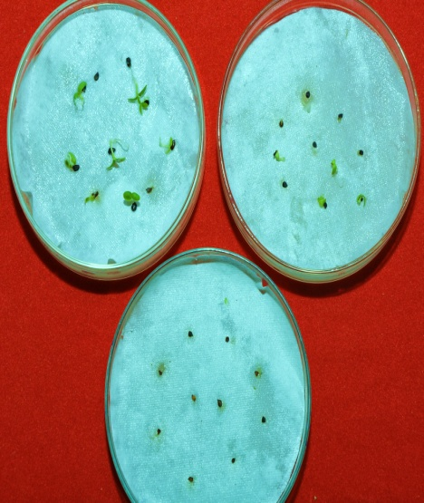
a

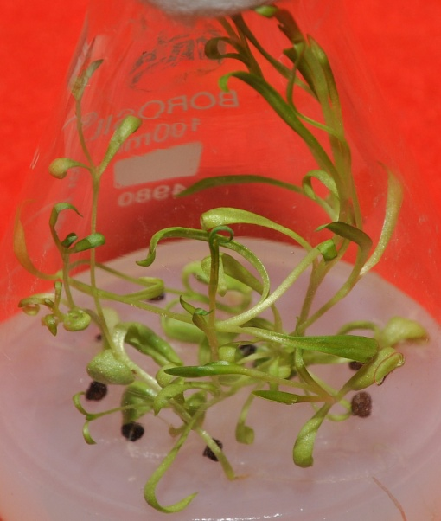
b

Figure 3

Morphogenic response of nodal explants of Dianthus caryophyllus cultured on MS medium supplemented with

- 0.2 mg/l BAP
- 0.5 mg/l BAP
- 1 mg/l BAP
- 2 mg/l BAP
- 3 mg/l BAP
- 5 mg/l BAP

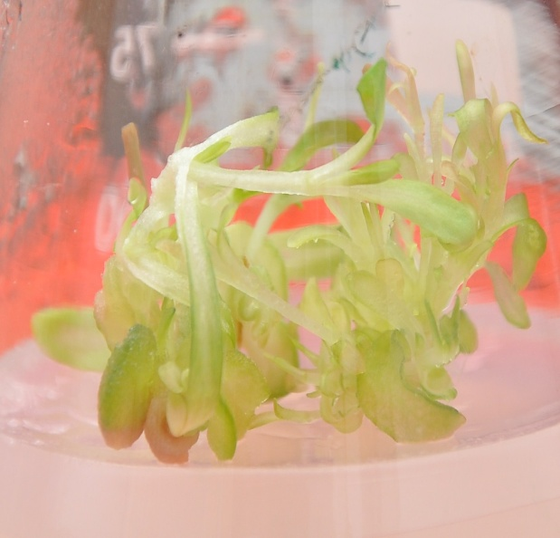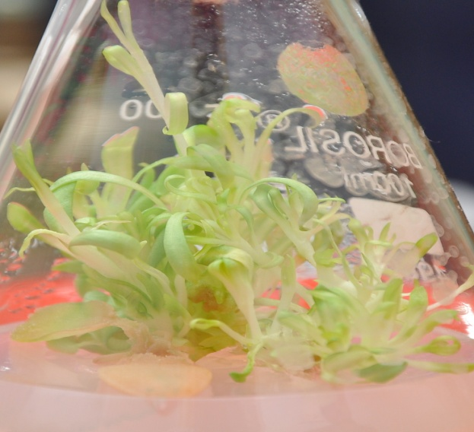
a
b
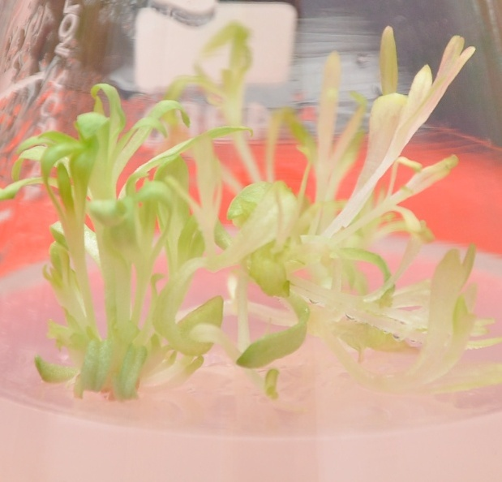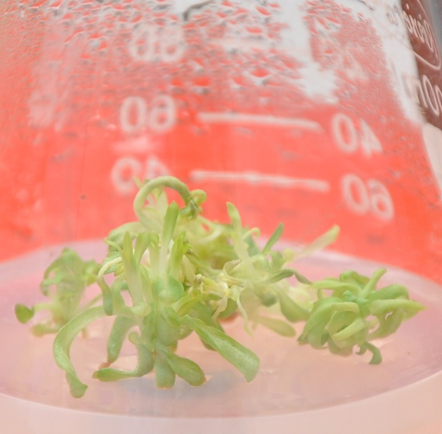
d
c
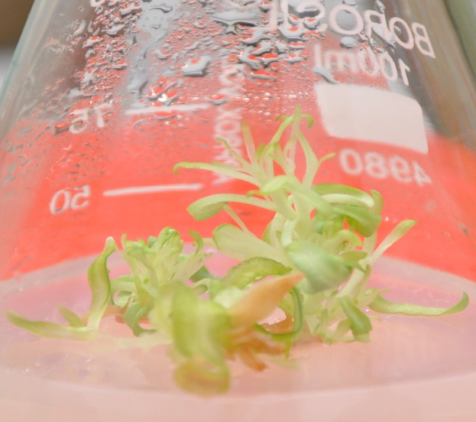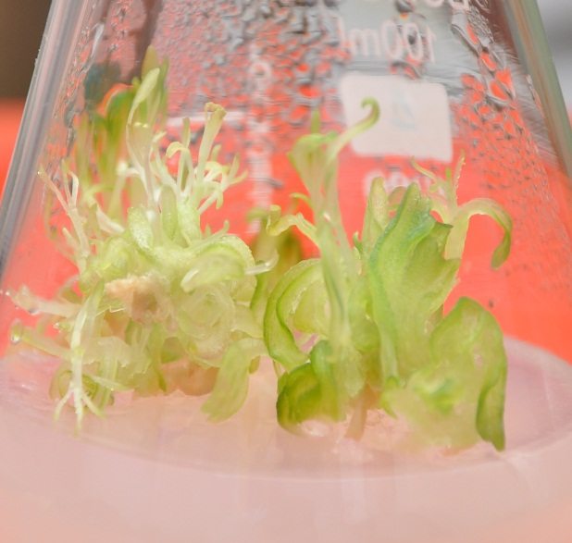
f
e

Figure 4

Morphogenic response of shoot tip explants of Dianthus caryophyllus cultured on MS medium supplemented with

- 0.2 mg/l BAP
- 0.5 mg/l BAP
- 1 mg/l BAP
- 2 mg/l BAP
- 3 mg/l BAP
- 5 mg/l BAP

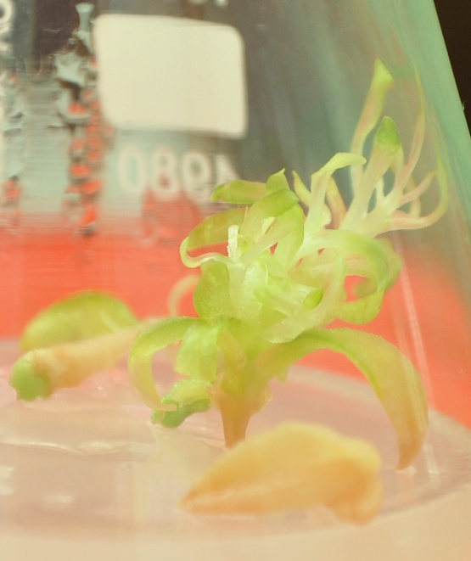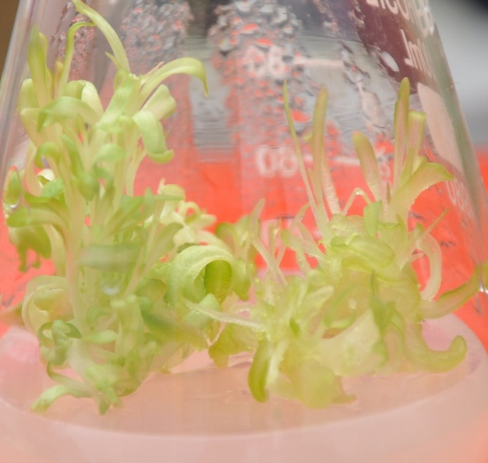
b
a
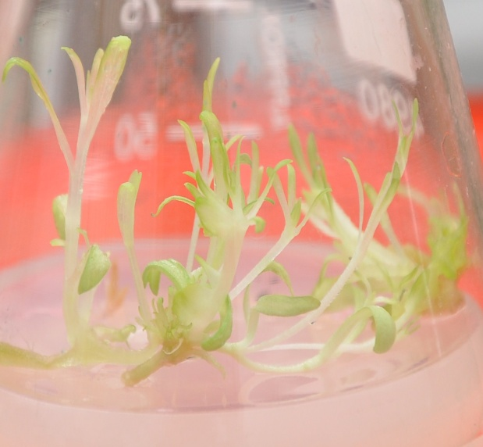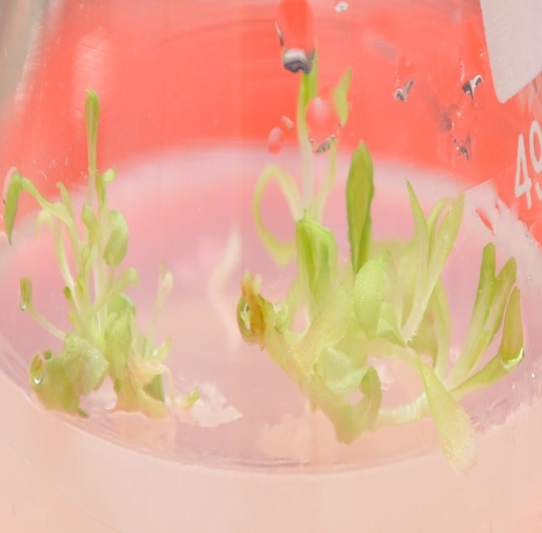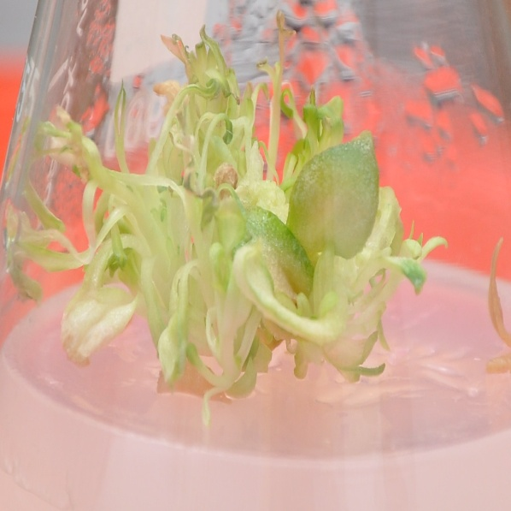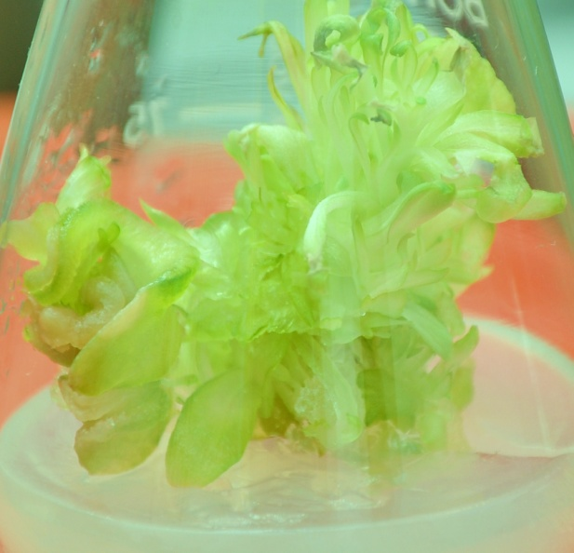
e
f
d
c

Table 2. Formation of shoot buds from mature seedling explant of Dianthus caryophyllus cultured on MS supplemented with BAP in combination with NAA

PGR (mg/l) |  | Mean no. of shoot ±S.D.
BAP | NAA | Node | Shoot tip
0.2 | 0 | 2.9± 0.6 | 3.3±0.8
0.2 | 0.1 | 6.3±0.8 | 5.5±0.9
0.2 | 0.2 | 7.2±0.7 | 6.9±1.1
0.5 | 0.1 | 6.5±0.9 | 5.3±0.9
0.5 | 0.2 | 8.5±0.7 | 7.2±0.8
0.5 | 0.5 | 11.5±0.6 | 9.2±0.7
1 | 0.1 | 4.8±0.8 | 3.9±0.8
1 | 0.2 | 3.5±0.7 | 3.3±0.9
1 | 0.5 | 3.2±0.8 | 2.9±0.7

Figure 5

(a-c) Morphogenic response of nodal explants on MS medium supplemented with BAP in combination with NAA

- MS+ BAP (0.2 mg/l ) +NAA (0.2 mg/l)
- MS+ BAP (0.5 mg/l ) +NAA (0.5 mg/l)
- MS+ BAP (1 mg/l ) +NAA (0.5 mg/l)

(d-f) Morphogenic response of shoot tip explants on MS medium supplemented with BAP in combination with NAA

- MS+ BAP (0.2 mg/l ) +NAA (0.2 mg/l)
- MS+ BAP (0.5 mg/l ) +NAA (0.5 mg/l)
- MS+ BAP (1 mg/l ) +NAA (0.5 mg/l)

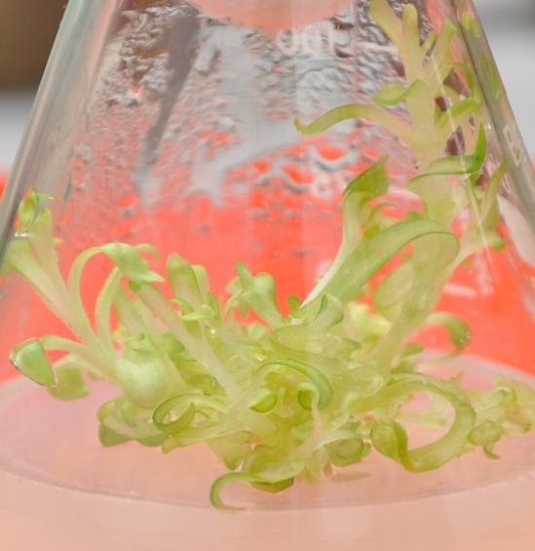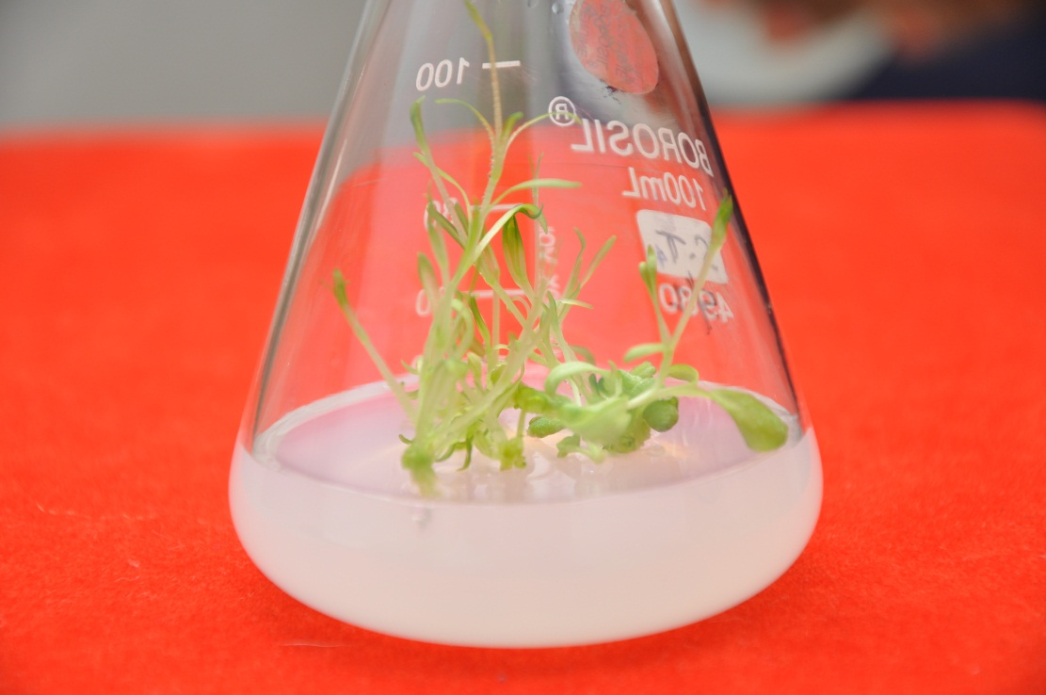
a

d

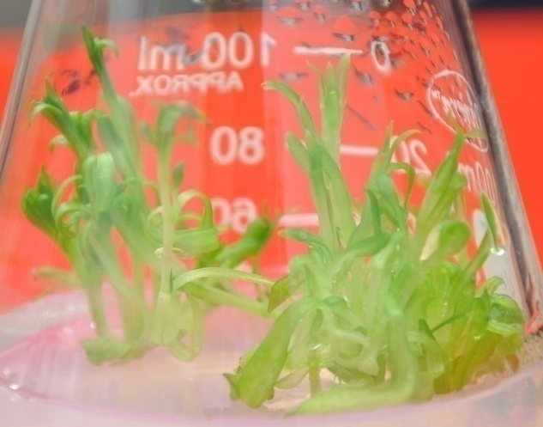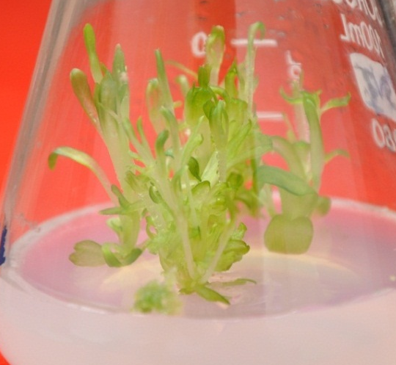
b

e

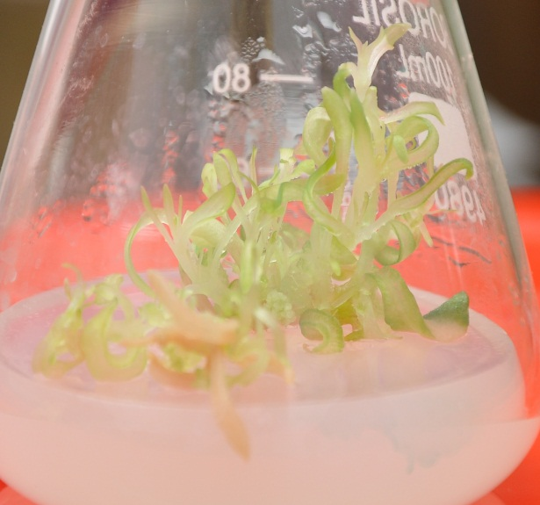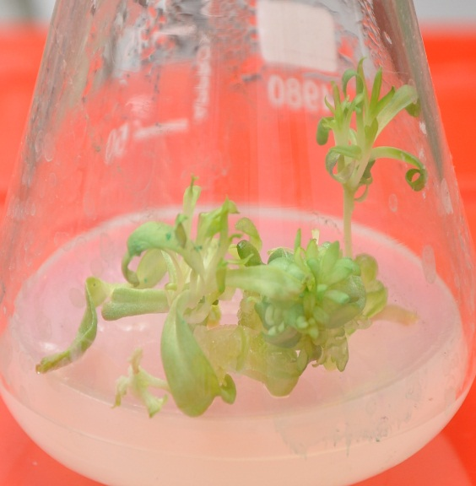
f

c

EFFECT OF HEAVY METALS (AgNO₃ &NiCl₂)
The effect of heavy metals (which are not constituent of MS media) was also investigated on the induction of shoot bud from nodes and shoot tips of Dianthus and the subsequent proliferation of primary shoots to form multiple shoots per explant.
B.1 Silver as Silver Nitrate (AgNO₃) (Table 3)
Node and shoot tip explants were cultured on MS medium supplemented with BAP (0.5 mg/l), NAA (0.5 mg/l) and different concentrations of AgNO₃ (0, 0.1, 0.5, 1 and 1.5 mg/l). Incorporation of AgNO₃ in to the medium induced positive response. The explants showed swelling during the first week of culture. The initiation of shoot bud induction occurred at the end of the second week of the culture. It was observed that the number of shoots increased with the increase in the concentration of AgNO₃ from 0.1 to 1mg/l. Beyond this level the shoots showed no significant increase in length but turned more hyperhydric. Best response in terms of total number of shoots as well as hyperhydricity per explant was achieved on medium containing 1 mg/l AgNO₃ (Fig.6, 7). Results achieved from AgNO₃ supplemented medium were better in terms of shoot regeneration and elongation of the shoots per explant than on control, lacking AgNO_{3.}
B.2 Nickel as Nickel Chloride (NiCl₂) (Table 4)
Node and shoot tip explants were cultured on MS medium supplemented with 0.5 mg/l BAP, NAA (0.5 mg/l) and different concentrations of NiCl₂ (0, 0.1, 0.5, 1 and 1.5 mg/l). The explants showed swelling during the first week of culture. The initiation of shoot bud induction occurred at the end of the second week of the culture. It was observed that the number of shoots decreased with the increase in the concentration of NiCl_{2.} The shoots that even developed up to 0.5 mg/l of NiCl₂ were hyperhydric and had abnormally large leaves (Fig. 8, 9). When the concentration of nickel chloride was raised to 1 and 1.5 mg/l NiCl₂, the abnormal condition of the shoots also increased.

AgNO₃(mg/l) | Mean no. of shoot bud ±S.D.
AgNO₃(mg/l) | Node | Shoot tip
0 | 4.8±0.9 | 3.8±1.1
0.1 | 5.2±1.6 | 4.1±0.7
0.5 | 5.5±1.6 | 4.4±0.6
1 | 5.9±1.2 | 4.9±0.9
1.5 | 4.4±0.9 | 3.5±0.8
Table3. Effect of silver nitrate on shoot bud formation from nodal and shoot tips of Dianthus caryophyllus cultured on MS supplemented with BAP (0.5mg/l) and NAA (0.5mg/l)

Table4. Effect of nickel chloride on shoot bud formation from nodal and shoot tips of Dianthus caryophyllus cultured on MS supplemented with BAP (0.5mg/l) and NAA (0.5mg/l)

NiCl₂ (mg/l) | Mean no. of shoot bud ±S.D.
NiCl₂ (mg/l) | Node | Shoot tip
0 | 4.8±0.9 | 3.8±1.1
0.1 | 3.4±0.8 | 3.1±0.8
0.5 | 3.0±0.7 | 2.8±0.7
1 | 2.7±0.7 | 2.5±0.6
1.5 | 2.5±0.8 | 2.2±0.6

Figure 6

Effect of silver nitrate on shoot bud formation from node of Dianthus caryophyllus cultured on MS supplemented with BAP (0.5 mg/l) + NAA (0.5 mg/l)

- Without AgNO₃

- 0.1 mg/l AgNO₃

- 0.5 mg/l AgNO₃

- 1 mg/l AgNO₃

- 1.5 mg/l AgNO₃

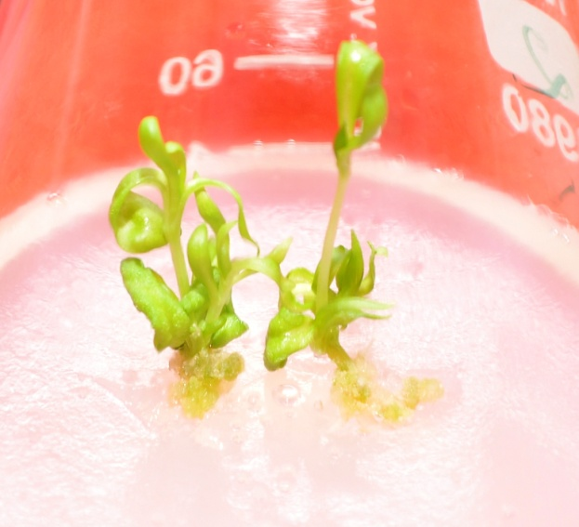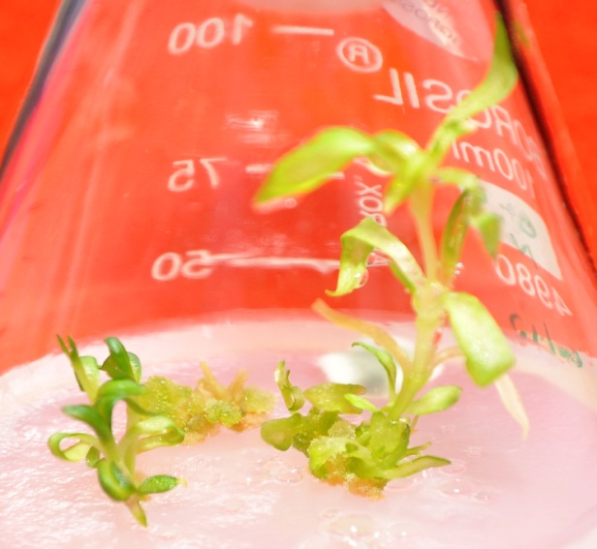
a
b
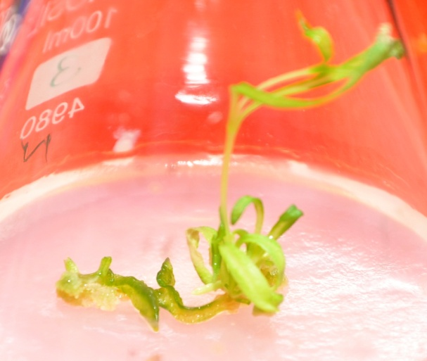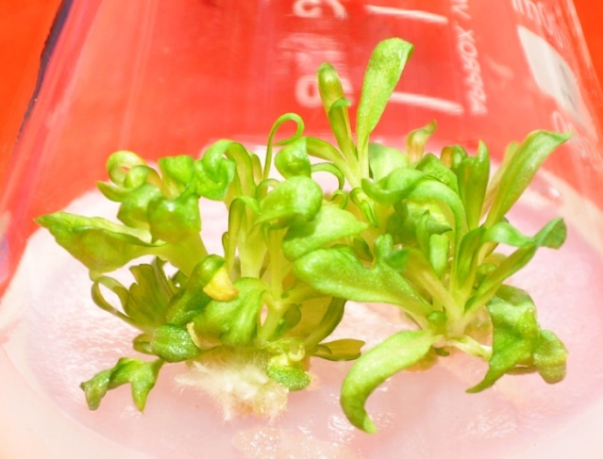
c
e
d

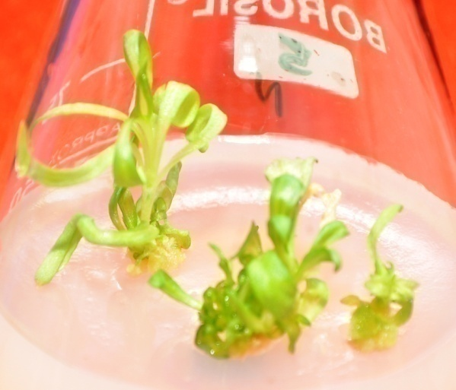
e

Figure 7

Effect of silver nitrate on shoot bud formation from shoot tip of Dianthus caryophyllus cultured on MS supplemented with BAP (0.5 mg/l) + NAA (0.5 mg/l)

- Without AgNO₃

- 0.1 mg/l AgNO₃

- 0.5 mg/l AgNO₃

- 1 mg/l AgNO₃

- 1.5 mg/l AgNO₃

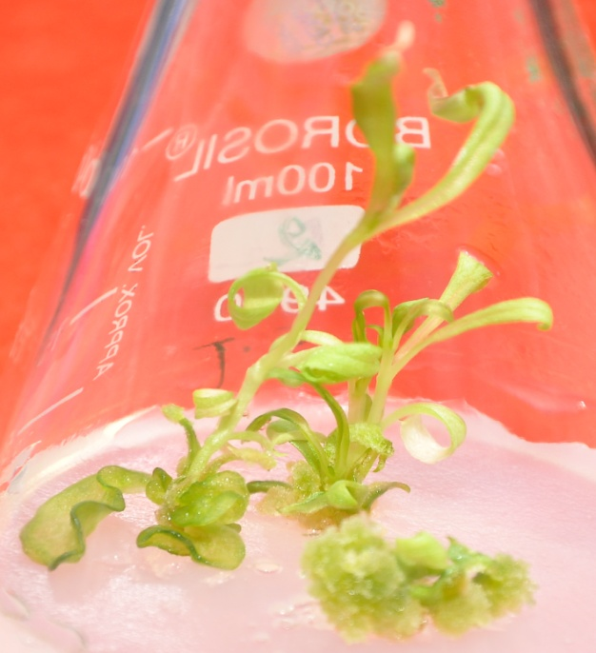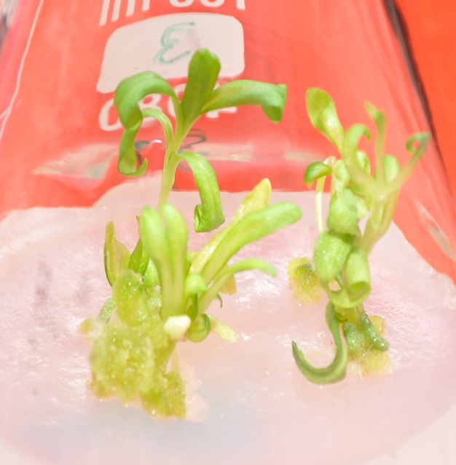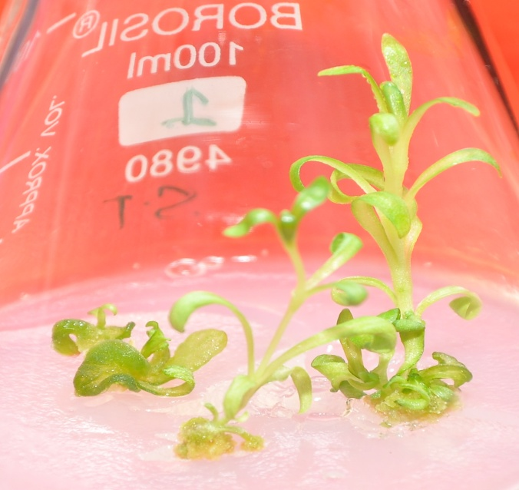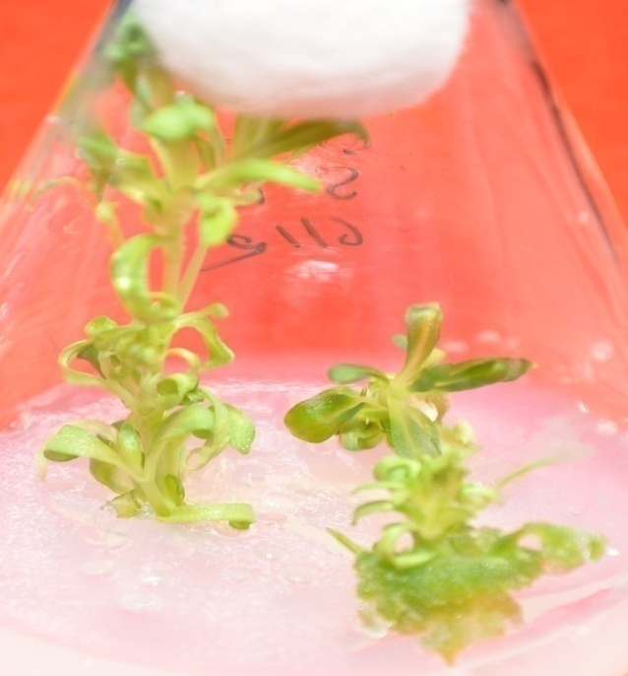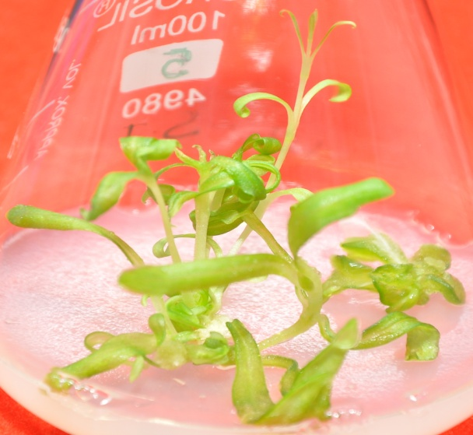
e
a
c
d
b

Figure 8

Effect of nickel chloride on shoot bud formation from node of Dianthus caryophyllus cultured on MS supplemented with BAP (0.5 mg/l) + NAA (0.5 mg/l)

- Without NiCl₂

- 0.1 mg/l NiCl₂

- 0.5 mg/l NiCl₂

- 1 mg/l NiCl₂

- 1.5 mg/l NiCl₂

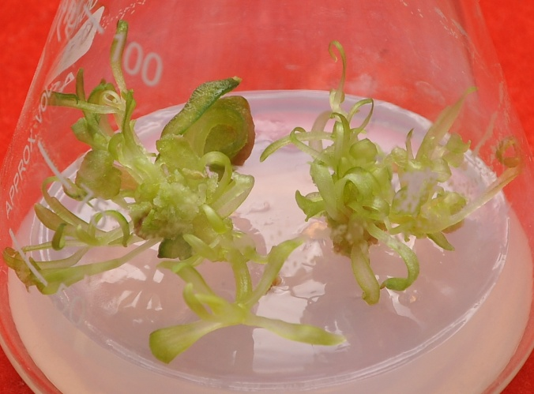
b
a
c
d
e
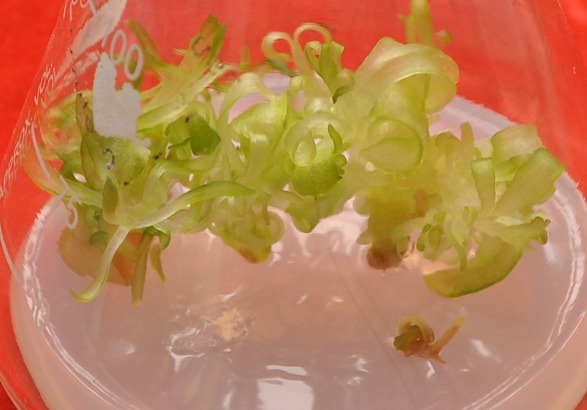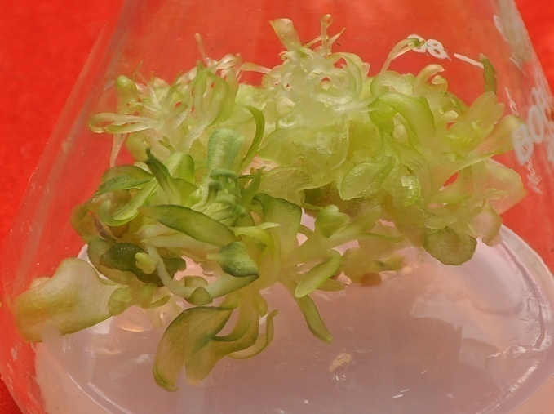
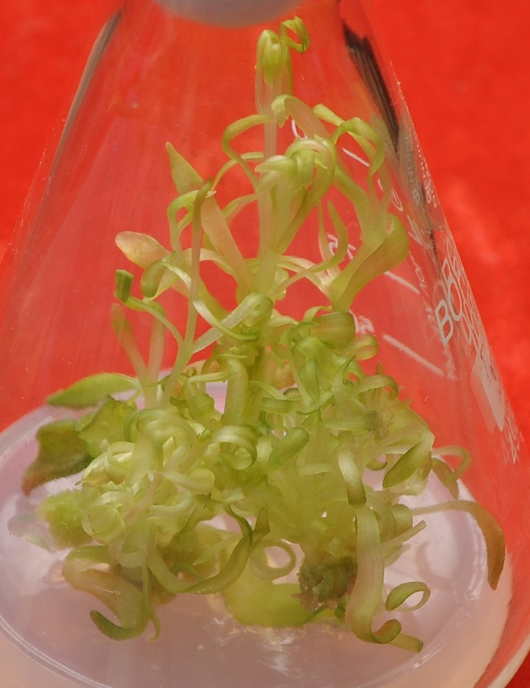

Figure 9

Effect of nickel chloride on shoot bud formation from shoot tip of Dianthus caryophyllus cultured on MS supplemented with BAP (0.5 mg/l) + NAA (0.5 mg/l)

- Without NiCl₂

- 0.1 mg/l NiCl₂

- 0.5 mg/l NiCl₂

- 1 mg/l NiCl₂

- 1.5 mg/l NiCl₂

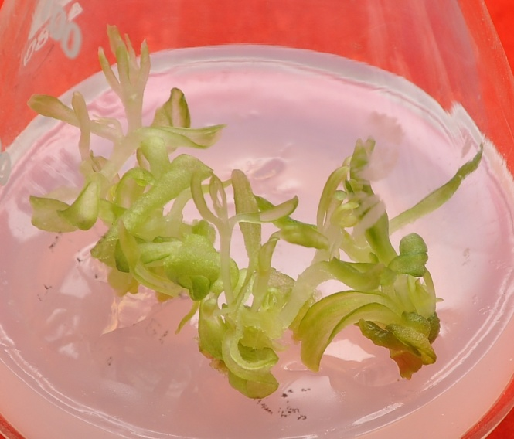
b
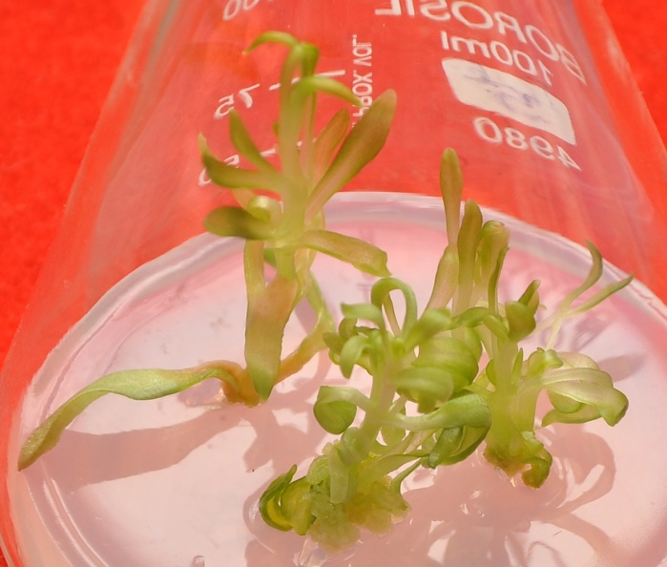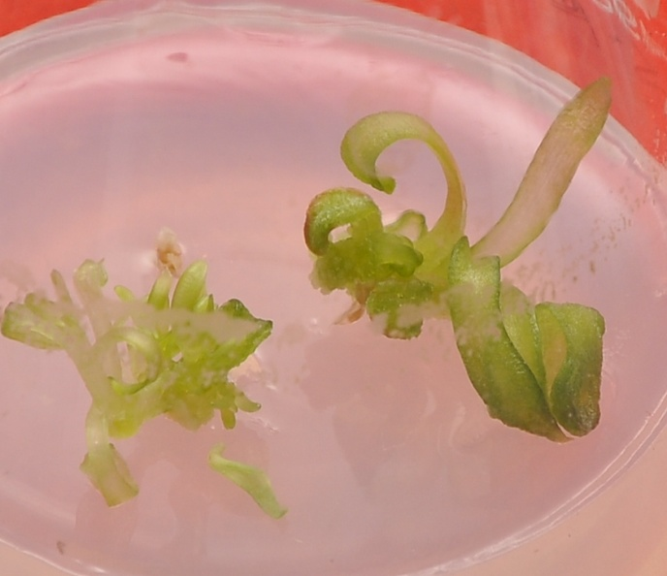
a
d
c
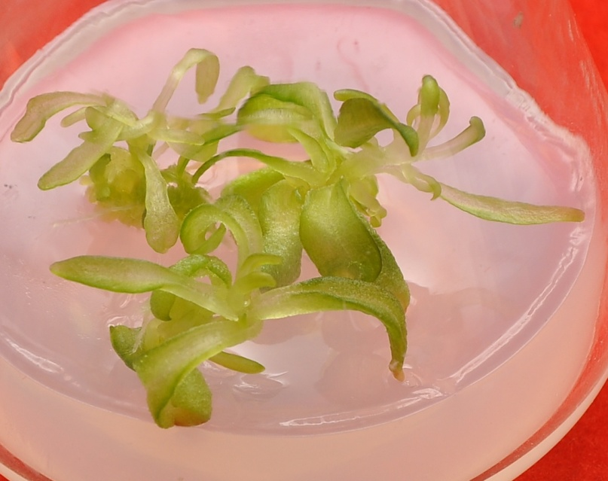
e

ROOTING OF IN VITRO REGENERATED SHOOTS
In vitro regenerated shoots (longer than shoots 2 cm) were excised and transferred into tubes containing solidified MS medium supplemented with various concentrations of auxins viz., IAA, IBA and NAA (0.5 and 1mg/ l) and half strength MS medium. 2-3thin, stout and slender roots induced from cut end of shoot on MS medium fortified with IBA (0.5 mg/l) (Fig. 10a).The addition of NAA (0.5 mg/l) to the MS medium promoted rooting, which was accompanied by callus (Fig. 10b).The MS medium supplemented with IAA (0.5mg/l) did not show any sign morphogenic response. On the other hand, the half strength MS medium showed excellent root formation where roots were long, unbranched and strong (Fig. 10c).

Figure 10

Rooting response of in vitro regenerated shoots of Dianthus caryophyllus cultured on MS medium supplemented with

- IBA (0.5 mg/l)
- NAA (0.5 mg/l)
- Half strength MS

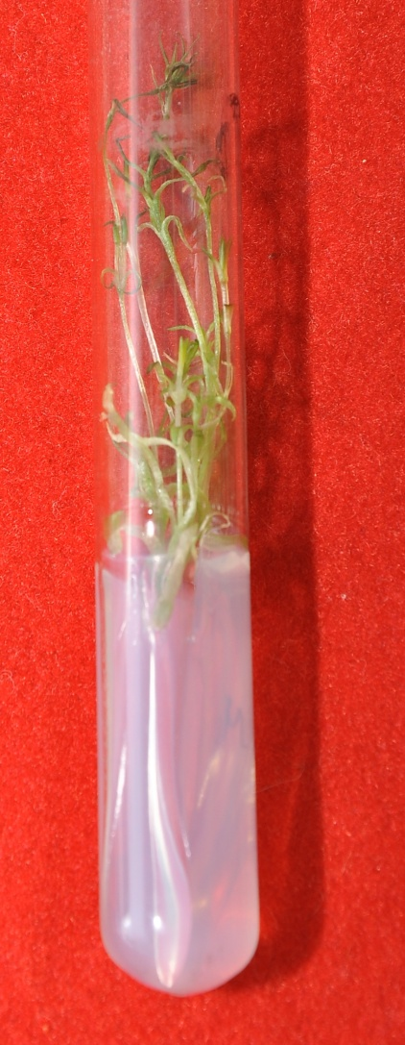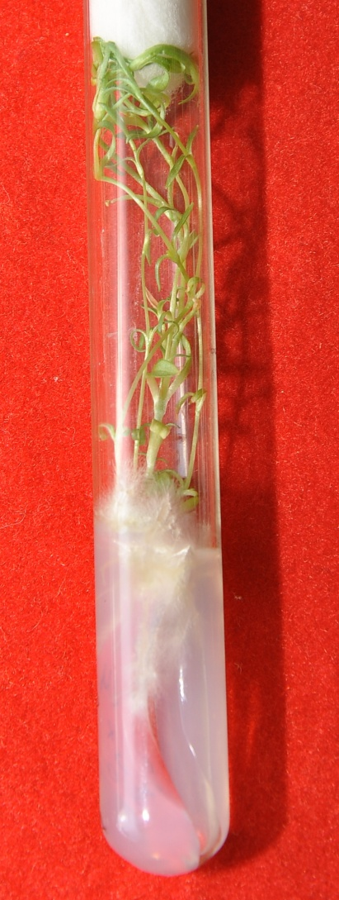
a\
b
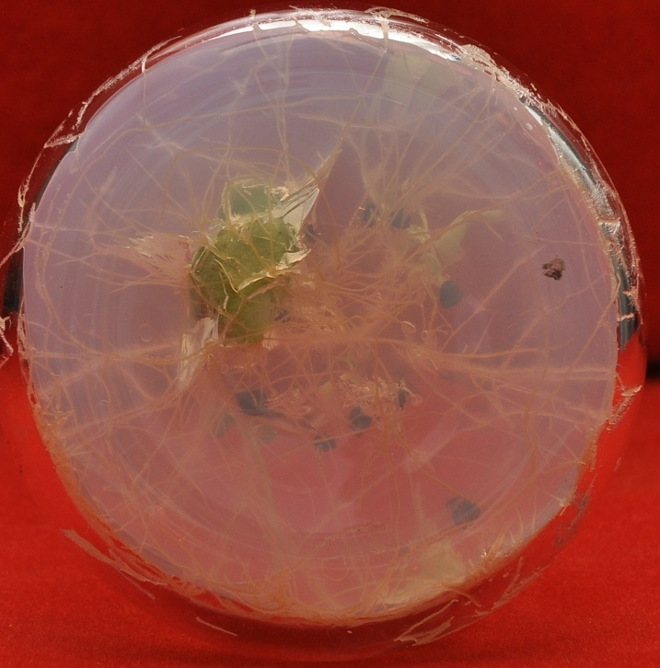
c

DISCUSSION

D. caryophyllus is a valuable plant and has a high potential for export and improvement of floriculture industry. Plant cell and tissue culture have been developed in recent years to such a level that any plant species either endangered or highly recalcitrant can be regenerated in vitro. This area of plant biotechnology is mainly concerned with manipulation and subsequent growth of cells, tissues, organs and plant cell. In tissue culture, the use of growth regulator play important role in influencing different plant processes comprising mostly of growth, differentiation and development such as culture establishment, shoot initiation, callogenesis, embryogenesis and rooting (Hobbie, 1998).
To facilitate the yield enhancement and quality improvement of D. caryophyllus, a range of in vitro tissue culture technique have been developed such as efficient systems have been established for the regeneration of plant from leaf explants and stem segments(Jethwani and Kothari,1996; Watad et al.,1996: Kantia and Kothari, 2002).

In present study, the shoot buds induced from the shoot tip and nodes explants were selected for further studies as it proved to be the best respondary explants for shoot regeneration. Nodal and apical segments have been used widely for shoot morphogenesis reported by Baker and Philips (1962).Similar results were reported by Earle and Langhans, 1975; Jethwani et al., 1994; Van Altvorest et al.,1995; Van Altvorst and Koehorst, 1995; Kallak et.al.,1997; Pareek et. al, 2004; H. Saehi, 2006; Danial et al.,2008; Duhoky et al., 2008; Ali et al.,2008.

Shoot tip and nodal explants were cultured on MS medium supplemented with various concentration of BAP (0.2, 0.5, 1, 2, 3 and 5 mg/l) for shoot regeneration. A maximum number of shoot buds formed per explant was obtained on MS medium supplemented with 0.5 mg/l BAP. This is in agreement with the studies of Lubomski and Jerry (1989) who reported the best shoot formation response of carnation on MS medium supplemented with BAP. Kovac (1995) also reported highest shoot multiplication in carnation in MS medium containing 1.0 mg/l BAP. However, Siddiqui (1993) and Duhoky et al., (2008) reported best shoot induction response in MS medium containing 5.0 mg/l kinetin.In the present investigation BAP in combination with NAA stimulated shoot buds induction and elongation response. It was found that MS medium supplemented with 0.5 mg/l BAP and 0.5mg/l NAA showed maximum shoot elongation and proliferation.

Van (1992) and Yantcheva et al., (1998) reported highest numbers of shoots per explant on MS medium containing 0.9 mg/l BA and 0.3 mg/l NAA. Mangel et al., (2002) and Onamu et al., (2003) used MS medium supplemented with combination of NAA and kinetin for shoot induction from meristem explant.
Elongated shoots of 2 cm or more in length were excised and placed onto rooting medium which consisted of half strength MS medium and MS medium supplemented with various concentrations auxins (IAA, IBA and NAA).Out of these medium the best response was obtained on half strength MS medium. However Amir et al (2009) reported best rooting response on MS medium containing 1.0 mg/l NAA. On the other hand best rooting of shoots was achieved when NAA was included in the culture medium at 0.5 mg/l concentration reported by Daniel et al., (2009).

The composition of MS medium is critical for optimizing the regeneration of plant in vitro. Some heavy metals act as microelements play important roles in the regeneration of plant at low concentration but at higher concentration they may cause reduction in growth for the most of plant species (Fernandes and Henrique, 1991; Claire et al., 1991). In our own results, For shoot regeneration explants cultured on induction medium supplemented with various concentration of heavy metals (AgNO₃ and NiCl₂), we found that shoot regeneration from nodal and shoot tip explants of D. caryophyllus on MS medium with AgNO₃ (1mg/l) appeared to be the most advantageous in terms of total number of shoots as well as hyperhydricity per explants but with NiCl₂ it is not beneficial for shoot regeneration.

Addition of sliver nitrate has been found to be effective in overcoming the recalcitrant behavior. Sliver nitrate act as ethylene inhibitor and used for shoot elongation in Capsicum reported by Phillips 1996).It acts as inhibitor of 1-aminocyclopropane -1-carboxylic acid which is a precursor of ethylene in biosynthetic pathway (Palmer, 1992). However Mohiuddin et al., (1997) achieved increased number of shoot in cucumber by incorporation of sliver nitrate. MS medium supplemented with sliver nitrate enhanced the frequency of shoot regeneration in Brassica species (Eapan and George, 1997). Gutiérrez-Miceli et al., (2010) reported additive effect of heavy metals in stimulating morphogenesis in callus redifferentiation has been reported using kinetin and AgNO₃ in D. caryophyllus. There has been many reports of the inhibitory effects of Ni on germination and growth in plants. Madhava et al., (2000) reported the germination of pigeon pea was decreased by addition of 1.5 mM Ni solution. Similar results were reported by Gajewska et al., (2006), who observed the inhibitory effect of 0.2 mM nickel on shoot growth of wheat. The roots of Nicotiana tabacum became dark brown within 7 to 10 days of exposure to 0.43 mM Ni and growth of the plants was severely inhibited (Boominathan et al., 2002). In the present study lower concentration of nickel chloride had deleterious effect on shoot induction and still higher concentrations of nickel chloride proved toxic.

Plant tissue culture is one of the most commonly used methods for induction of shoot buds. We have demonstrated here that providing optimal concentration of BAP (0.5mg/l) and NAA (0.5mg/l) in MS medium which is induced shoot buds from the explants of D. caryophyllus. Addition of silver nitrate in the medium is applicable to improve the quality and quantity of the regenerated shoots while on the other hand adding nickel to the medium proved detrimental.

SUMMARY

The present work deals with interactive effect of different plant growth regulator and heavy metals on shoot morphogenesis of Dianthus caryophyllus. This plant is a member of the family caryophyllaceae and is the most common cultivated species of this family which is characterized by their excellent keeping quality, wide range of forms, ability to withstand long distance transportation and remarkable ability to rehydrate after continuous shipping. It shows high level of heterogeneity in seed population which act as constraint to propagation of agronomic traits and for commercial seed production. Considering the benefits of this plant and to fulfill the world’s demand for carnation, the technique of micropropagantion has been widely used. Tissue culture offers an opportunity to access clean planting material and provides a start in production of good quality carnation cut flowers that can adequately compete in the international markets.

The seeds of D. caryophyllus were obtained from Namdhari Seed Agency, Bengaluru.After proper sterilization seeds were germinated on half strength MS medium solidified with 0.8% (w/v) agar. Various explants were taken for the studies; shoot tip and nodal explants showed better response in term of shoot regeneration. The explants cultured on MS medium supplemented with various concentration of BAP (0.2-5mg/l). The maximum number of shoot buds was obtained on MS medium supplemented with BAP (0.5mgl/) and NAA (0.5mg/l). The shoot buds induced and proliferated on medium supplemented with BAP (0.5mg/l) and NAA (0.5mg/l) were selected for further studies as it proved to be the best concentration for shoot induction. The shoots were elongated on MS supplemented with BAP (0.5mg/l) and NAA (0.5mg/l), prior to rooting on half strength MS medium. Various auxins (IBA, IAA and NAA) were tried for rooting. The best response was shown by half strength MS medium.

Effect of heavy metals (AgNO₃ and NiCl₂) was investigated on shoot morphogenesis in D. caryophyllus. Node and shoot tip explants were cultured on induction medium (0.5 mg/l BAP + 0.5 mg/l NAA) supplemented with various concentrations of AgNO₃ (0, 0.1, 0.5, 1 and 1.5 mg/l).
It was observed that the number of shoots increased with the increase in the concentration of AgNO₃ from 0.1 to 1mg/l. Beyond this level the shoots showed no significant increase in length but turned more hyperhydricity. Effect of NiCl₂ was found to be not advantageous for shoot morphogenesis in Dianthus.

REFERENCES

- Abeles, F.B. (1973) Ethylene in plant biology. Academic press New York. 302: ISBN 978-0120414505

- Ali, A., H. Afrasiab, S. Naz, M. Rauf and J. Iqbal (2008) An efficient protocol for in vitro propagation of carnation (Dianthus caryophyllus) Pak. J. Bot.40(1): 111-121

- Aminuddin, S. K. R., K. M. Srivastava and B. P. Singh (2007) Natural infection of cucumber mosaic virus on Dianthus barbatus in India. Plant Pathol.42(5): 811-813

- Assuncao, A., H.Schat and M. Aarts (2003) Thlaspicaerulescens, an attractive model species to study heavy metal hyperaccumulation in plants.New Phytol.159:351–360

- Bais, H., J. George and G. Ravishankar (1999) Influence of polyamines on growth of hairy root cultures of witl of chiocory (ChichoriumintybusL cv Lucknow local) and formation of coumarins. J. of PGR.18: 33-37

- Bais, H., G.S. Sudha, and G. Ravishankar (2000a) AgNO3 influences in vitro root formation in DecalepishamiltoniiWight, Arn. Curr.Sci. 79:894-898

- Bais, H., G.S. Sudha, and G. Ravishankar (2000b) Putrescine and AgNO3 influences shoot multiplication Invitro flowering and endogenous titres of polyamines in ChichoriumintybusL cv Lucknow Local. J. of PGR.19:238-248

- Bais, H., G.S. Sudha, and G. Ravishankar (2001a) Influence of putrescine AgNO3 and polyamine inhibitors on the morphogenetic response in untransformed and transformed tissues of Chichoriumintybusand their regenerants. Plant Cell Reports.20: 547-555

- Bais, H., G.S. Sudha and G. Ravishankar (2001b) Putrescine influences growth and production of coumarins in transformed and untransformed root cultures of witloof chicory (ChichoriumintybusL cv Lucknow Local). Acta.Physio.Plant.23:319-327

- Bais, H., R. Venkatesh and G. Ravishankar (2001c) Agrobacterium rhizogenes mediated transformation of witl of chiocoryin vitro shoot regeneration and induction of flowering. Curr. Sci. 80: 83-87

- Baker, R. and D. J. Philips (1962) Obtaining pathogen free stock by shoot tip culture. Phytopathol.52: 1242-1244

- Beyer, E. M. (1976a) A potent inhibitor of ethylene action in plants. Plant Physiology.58:268-271

- Beyer, E.M. (1976c) Silver ion a potent anti-ethylene agent in cucumber and tomato. HortScience.11: 175-196

- Biddington, N.L. (1992) The influence of ethylene in plant tissue culture. Plant Growth Regulation.11:173-178

- Birch, R. (1997) Plant transformation: problems and strategies for practical applications. Annu. Rev. Plant Physiol. Plant Mol. Biol. 48: 297–326

- Bird, R. (1994) Border Pinks pp. 1-174 Timber Press, Portland, Oregon, USA

- Boominathan, R. and P.M. Doran (2002) Nickel induced oxidative stress in roots of Ni hyperaccumulater Alyssum bertolonii. New Phytol.156:205–215

- Casanova, E., A.E. Valdés L. Moysset and M.I. Trillas (2004) A Levels and immunolocalization of endogenous cytokinins in thidiazuron-induced shoot organogenesis in carnation. J. Plant Physiol.

- Cassells, A. C. and R. F.Curry (2001) Oxidative stress and physiological, epigenetic and genetic variability in plant tissue culture: implications for micropropagators and genetic engineers. Plant Cell Tiss. Org. Cult. 64: 145–157

- Chen,C., D.Huang and J Liu (2009) Functions and toxicity of nickel in plants: recent advances and future prospects. Clean 37:304–313

- Chi, G.L. and E.C. Pua (1989) Ethylene inhibitors enhanced de novo shoot regeneration from cotyledons of Brassica campastris spp in vitro. Plant Science.64: 243-250

- Choudhary, M. L. and C. K. Chin (1995) Somatic embryogenesis in cell suspension culture of carnation (Dianthus caryophyllus L.) Plant Growth Regulation 16: 1-4

- Chraibi, K. M., A. Latche, J. P. Roustan and J. Fallot (1991) Stimulation of shoot regeneration from cotyledons of Helianthus annus by ethylene inhibitors, silver and cobalt. Plant Cell Rep.10: 204-207

- `Danial, G. H., A. N. Yousif and M. S. Omar (2009) Clonal propagation of Dianthus caryophyllus L. through tissue culture. J. Duhok. Univ.12(1): 91-95

- De Block, M., D. De Brouwer and P. Tennig (1989) Transformation of Brassica napus and Brassica oleracea using Agrobacriumtumefaciens and the expression of the bar and neo genes in the transgenic plants.Plant Physiol.91: 694-701

- Demmink, J. F., J. B. M. Clusters and J. H. W. Bergervoet (1987) Gynogenesis to bypass crossing barriers between diploid and tetraploid Dianthus species. Acta horticulture.212: 167-176

- Duhoky, M. S., M. A. Salman and M. E. M. Amin (2009) Micropropagation of carnation (Dianthus caryophyllus). J. Duhok Univ. 12(1): 61-66

- Eapen, S. and L George (1997) Plant regeneration from peduncle segments of oil seed brassica species: Influence of AgNO3 and silver thiosulphate. Plant Cell Tissue and Organ Culture.51:229-232

- Earle, E. D. and R. W. Langhans (1975) Carnation propagation from shoot tips cultured in liquid medium. Hort. Science. 10: 608- 610

- Fernandis, J.C. and F.C. Henriques (1991) Biochemical physiological and structural effects of excess copper in plant. Bot.Rev.57: 246-273

- Gajewska, E., M. Sklodowska, M. Slaba and J. Mazur (2006) Effect of nickel on antioxidative enzyme activities, proline and chlorophyll content in wheat shoots. Biol Plant 50:653–659

- Gajewska E., M. Wielanek, K. Bergier and M. Skłodowska (2009) Nickel induced depression of nitrogen assimilation in wheat roots. ActaPhysiol Plant 31:1291–1300

- Gautheret, R. (1939) Sur la possibilite de realiser la culture indefinie des tissus de tubercules de carotte. C. R. Acad. Sci., Paris, 208: 118-120

- Ghosh, S. (1987) Micropropagation of Sim’s carnation (Dianthus caryophyllus L.) Indian J. Exp. Biol. 24: 703-704

- Gutierrez-Miceli, F. A., L. Arias, N. Juarez-Rodriguez, M. Abud-Archilla, A. Amaro-Reyes and L. Dendooven (2010) Optimization of growth regulators and silver nitrate for micropropagation of Dianthus caryophyllus L. with the aid of a response surface experimental design. In Vitro Cell Dev. Biol.Plant 46: 57-63

- Hilderbrandt, A. (1946) Culture du tissus cambial. C. R. Acad. Sci. Paris. 198: 2195- 2196

- Hobbie, L.J.(1998) Auxin : molecular genetic approaches in Arabiddopsis.Plant Physiol.Biochem.36:91-102

- Hussain, I., A. Mushtaq and A. Qureshi (1994) In vitro multiplication of Dianthus caryophyllus L. cv. CSU.Pink and White Sim.Sarhad J. Agri. 10: 539-546

- Jain, A., A. Kantia, S.L. Kothari (2001) De novo differentiation of shoot buds from leaf-callus of Dianthus caryophyllus L. and control of hyperhydricity .Sci Hoti. 87:319-326

- Jethwani, V. and S. L. Kothari (1993) Micropropagation of D.barbatusand D. chinensis through cotyledonary node culture.Plant Cell Tiss. Org. Cult.3: 91-96

- Jethwani, V., Sharma V. and S. L. Kothari (1994) Micropropagation of Dianthus chinensis and D. barbatus through shoot tip culture.J. Bot. Society. 73: 357-358

- Jethwani, V. and S. L. Kothari (1996) Phenylacetic acid induced organogenesis in culture leaf segments of Dianthus chinensis. Plant Cell Rep. 5: 869-872

- Kabata-Pendias, A.and H. Pendias (2001) Trace elements in soils and plants, 3rd edn. CRC Press Inc, Boca Raton.FL. 413

- Kallack, H., I. Hilpus and K. Virmuae (1996) Influence of genotype and growth regulations on morphogenetic process in carnation shoot apex cultures. Sci. Hort.65: 181-189

- Kantia, A. and S. L. Kothari (2002) High efficiency adventitious shoot bud formation and plant regeneration from leaf explants of Dianthus chinensis L. Sci. Hort.96: 205-212

- Karami, O. (2008) Induction of embryogenic callus and plant regeneration in carnation (Dianthus caryophyllus L.) Online J. Biol. Sci. 8(4): 68-72

- Knop,W. (1865) Quantitative Untersuchungenuber die Ernahrungsprocesse der Pflanzen. Landwirtsch.Vers.Stn.7: 93.

- Kotte, W. (1992) KulturversuchemitisoliertenWurzelspitzen. Beitr.Allg.Bot. 2: 413-434.

- Kovac, J. (1995) Micropropagation of Dianthus caryophyllus sub sp. Bohemicus-an endangered endemic from the Czech Republic. Biol.37: 27-33.

- Krupa,Z. A.Siedlecka, W. Maksymiec and T. Baszynski (1993) In vitro responses of photosynthetic apparatus of Phaseolus vulgaris L.to nickel toxicity. Plant Physiol 142:664–668

- Lau, Oi-Lim and Yang, F. Shang (1976) Inhibition of ethylene production by cobaltous ion. Plant Physiology.58:114-117

- Leshem, B., E. Werker and D. P. Shalev (1988) The effect of cytokinins on vitrification in melon and carnation. Ann. Bot. 62: 271-276

- Lieberman, N. (1979) Biosynthesis and action of ethylene. Annual Review of Plant Physiology.30 :533-591

- Lumbomski, M. and M. Jerzy (1989). In vitro propagation of pot carnation from stem intertnodes.Acta Hort. 251: 235-240

- Mangal, M., S.V. Bhardwaj, D.R. Kaur and A.K. Mangal (2002) Use of meristem tip culture to eliminate carnation latent virus from carnation plant.Ind. J. Exp. Biol. 40: 119-122

- Manoj, K., A.K. Yadav and G.K. Garg (2003) Development of suitable protocol to overcome hyperhydricity in carnation during micropropagation. Plant Cell, Tissue and Organ Culture 72: 153–156

- Marschner, H., (1995) Mineral nutrition of higher plants, 2nd edn. Academic Press, London, p 889

- Mattoo, A.K. and J.C. Suttle (1991) The plant hormone ethylene. CRC press. Boca Raton, Florida. 337:ISBN 0-8493-4566-9

- Messeguer, J., M. C. Arconada and E. Mele (1993) Adventitious shoot regeneration of carnation (Dianthus caryophyllus L.) Sci. Hort.54: 153-163

- Mii, M., M. Buiatti and F.Gimelli (1990) Carnation. In: Ammirato, P.V., Evans, D.R., Sharp, W.R., Bajaj, Y.P.S. (Eds.), Handbook of Plant Cell Culture. McGraw-Hill, New York, 284-318

- Miller, R. M., V. Kaul, J. F. Hutchinson, G. Maheswaran and D. Richards (1991) Shoot regeneration from axillary buds of carnation (Dianthus caryophyllus L.) Ann. Bot. 67: 35-42

- Miller, R. M., V. Kaul, J. F. Hutchinson, G. Maheswaran and D. Richards (1992) Shoot regeneration from fragmented flower buds of carnation (Dianthus caryophyllus L.). Ann. Bot. 68: 563-568

- Mohinuddin, A.K., M.K. Chowdhury,S. Napis and A.C. Abdulla (1997) Effect of AgNO3 on Cucumber in vitro shoot regeneration .Plant Cell Org cult. 51:75-78

- Molas, J., (2002) Chasnges of chloroplast ultrastructure and total chlorophyll concentration in cabbage leaves caused by excess of organic Ni II complexes. Environ. Exp. Bot. 47:115–126

- Moyal-Ben Zvi, M. and A. Vanstein (2007) Carnation.Biotechnology in Agriculture and Forestry.Transgenic Crops VI (edn by E. C. Puz and M. R. Davey) 61.

- Murashige, T. and F. Skoog (1962) A revised medium for rapid growth and bioassays with tobacco tissue cultures.Physiol. Plant.15: 473-497

- Nakano, M., Y. Hashino and M. Mii (1994) Adventitious shoot regeneration from cultured petal explants of carnation. Plant Cell Tiss. Org. Cult.36: 15-19

- Nontaswatsri, C. and S. Fukai (2005) Regenerative callus of Dianthus ‘Telstar Scarlet’ showing mixploidy produce diploid plants. Plant Cell Tiss. Org. Cult.83: 351-355

- Nugent, G., T. Wardley and C. Lu (1991) Plant regeneration from stem and petal of carnation (Dianthus caryophyllus) Plant Cell Rep.10: 477-453

- Onamu, R., S.D. Obukosia, N. Musembi and M.J. Hutchinson (2003) Efficacy of Thidiazuron in In vitro propagation of carnation shoot tips: Influence of dose and duration of exposure. Afr.Crop Sci. J. 11(2): 125-132

- Pareek, A. and S. L. Kothari (2003) Direct somatic embryogenesis and plant regeneration from leaf cultures of ornamental species of Dianthus. Sci. Horti.

- Pareek, A., A. Kantia and S. L. Kothari (2004) In vitro cloning of ornamental species of Dianthus.Ind. J. Biotech.3: 363-266.

- Petru, E. and Z. Landa (1974) Organogenesis in isolated carnation plant callus tissue cultivated in vitro. Biol. Planta.16: 450-453

- Phillips G.C. (2004) In vitro morphogenesis in plant recent advances. In vitro Cell Dev Biol Plant.40:342-345

- Preece, J. E. (1995) Can nutrient salts partially substitute for plant growth regulators? Plant Cell Tissue and Organ Cult.35:131-139

- Pua, E.C. and G.L Chi (1993) De novo shoot morphogenesis and plant growth of mustard (Brassica juncea) in vitro in relation to ethylene. PhysiologiaPlantarum.88: 467-474

- Purnhauser, L., P. Medgysey, M Czako, J.P. Dix and L. Marton (1987) Stimulation of shoot regeneration in Triticumaestivumand NicotianaplumbaginifoliaViv tissue cultures using the ethylene inhibitor silver nitrate. PlantCell Reports. 6:1-4

- Rao, K. and T. Sresty (2000) Antioxidative parameters in the seedlings of pigeonpea (Cajanuscajan L.) Millspauga in response to Zn and Ni stress.Plant Sci.157:113–128

- Roustan, J.P., A. Latche and J.Fallot (1990) Control of carrot somatic embryogenesis by AgNO3 an inhibitor of ethylene action effect on arginine decarboxilase activity. Plant Science.67:89-95

- Roustan, J.P., A. Latche and J. Fallot (1989) Stimulation of Daucuscarotasomatic embryogenesis by inhibitors of ethylene biosynthesis: cobalt and nickel. Plant Cell Reports.8: 182-185

- Sajid, G. M. and S. Pervaiz (2008) Bioreactor mediated growth, culture ventilation, stationary and shake culture effects on in vitro growth of sugarcane. Pak. J. Bot.40(5): 1949-1956

- Salehi, H. (2006) Can a general shoot proliferation and rooting medium be used for a number of carnationcultivars? Afr. J. Bio.5:25-30

- Sankhla, D., N. Vavis, N. Sanklha and A. Upadhya (1994) In vitro regeneration of heat tolerant “German Red” carnation through organogenesis and somatic embryogenesis. Gartenbouwissenschaft.6: 227-233

- Seo, J., S. W. Kim and S. R. Min (2007) High frequency somatic embryogenesis and plant regeneration in root explant cultures of carnation. Plant Biotecnol. Rep.1: 67-70

- Sethi, U., A. Basu and S. Guha-Mukherjee (1990) Control of cell proliferation and differentiation by modulators of ethylene biosynthesis and action in Brassica hypocotyl explants. Plant Sci. 69: 225-229

- Sharma, P. and R. Bhardwaj (2008) Effect of 28-homobrassinolide on nickel uptake, protein content and antioxidativedefence system in Brassica juncea. Biol Plant. 52:767–770

- Siddiqui, F.A. (1993) A study of the elimination of sugarcane mosaic virus from Saccharum officinarum by means of In vitro meristem and callus culture and some biochemical aspects of regenerated healthy and infected plants. Ph.D. thesis.Department of Botany, University of thePunjab, Lahore, Pakistan.

- Skirvin, R., K. McPheeters and M. Norten (1994) Source and frequency of somaclonal variation. Hort Science. 29: 1232–1237

- Songstad, D.D., D.R Duncan and J.M Widholm (1988) Effect of 1-aminocycopropane-1-carboxilic acid silver nitrate and norbornadiene on plant regeneration from maize callus cultures. Plant Cell Reports.7: 262-265

- Susek, A., B. Javornik and B. Bohanec (2002) Factors affecting direct organogenesis from flower explants of Allium giganteum.Plant Cell Tiss.Org. Cult. 68: 27–33

- Van Altvorst, A. C. and H. J. J. Koehorst (1995) Cells within the nodal region of carnation shoots exhibit a high potential for adventitious shoot formation. Plant Cell Tiss. Org. Cult.40: 151-157

- Van Altvorst, A. C., H. J. J. Koehorst, J. D. Jong and J. J. M. Dons (1996) Transgenic carnation plants obtained by Agrobacterium tumefaciens mediated transformation of petal explants. Plant Cell Tiss. Org. Cult.45: 2

- Van Altvorst, A. C., H. J. J. Koehorst, T. Bruinsma, J. Jansen, J. M. B. Custers, J. De Jong and J. J. M. Dons (1992) Adventitious shoot formation from in vitro leaf explant of carnation(Dianthus caryophyllus L.) Sci. Hort. 51: 223-235

- Van, A., A.C. Bruinsma, T. Koehorst, H.J.J. and J.J.M. Dons (1992) Regeneration of carnation (Dianthus caryophyllus) using leaf explants.Acta Hort. 307: 109-116.

- Varshney, A., M. Lakshmikumaram, P. S. Srivastava and V. Dhawan (2001) Establishment of genetic fidelity of in vitro raised Liliumbulblets through RAPD markers. In vitro Cell Dev. Biol.-Plant.37: 227-231

- Villalobos, V. (1981) Floral differentiation in carnation (Dianthus caryophyllus) from anthers cultured in vitro. Phyton.41: 71-75

- Watad, A., A. Ahroni, A. Zuker, H. Shejtman, A, Nissim and A.Vainstein (1996) Adventitious shoot formation from carnation stem segments: a comparison of different culture procedures. Sci. Hort. 65: 313-320

- Welsh, J. and M. McClelland (1990) Fingerprinting genomes using PCR with arbitrary primers. Nucl. Acids Res. 8: 7213-7218

- Werker, E. and B. Leshem (1987) Structural changes during vitrification of carnation plantlets. Ann. Bot. 59: 377-385

- White, P. (1934) Potentially unlimited growth of excised tomato root tips in a liquid medium. Plant Physiol. 9: 585-600.

- Xylander, M. W. Braune (1994) Influence of nickel on the green alga Haematococcus lacustris Rostafinski in phases of its life cycle. J Plant Physiol. 144:86–93

- Yadav, M. K., A. K. Gaur and G. K. Garg (2003) Development of suitable protocol to overcome hyperhydricity in carnation during micropropagation.Plant Cell Tiss. Org. Cult.72: 153-156

- Yang, S.F. (1985) Biosynthesis and action of ethylene.HortScience.20 :41-45

- Yang, S.F. and N. Hoffman (1984) Ethylene biosynthesis and its regulation in higher plants.Annual Review of PlantPhysiology.35:155-189

- Yantcheva, A., M. Vlahova and A. Antanassov (1998) Direct somatic embryogenesis and plant regeneration of carnation (Dianthus caryophyllus L.) Plant Cell Rep.18: 148-153

- Yusuf, M., Q.Fariduddin, S.Hayat, S.A. Hasan and A. Ahmad (2010) Protective responses of 28 homobrssinolide in cultivars of Triticumaestivum with different levels of nickel. Archv Environ ContamToxico(in press)

