**ABSTRACT FOR ORAL PRESENTATION**

**Molecular Complex : Supramolecular two component three dimensional gel**

**Jyotsna S. Meshram, Devendra S. Raghuvanshi**

**School of Chemical Sciences, North Maharashtra University, Jalgaon (MS), INDIA**

[drjsmeshram@gmail.com](mailto:drjsmeshram@gmail.com)

**Abstract:**

Supramolecular chemistry is an important area for the molecular recognition of molecules. Herein in this presentation we report receptor temperature dependent architecture constructed acting as host having covalent organic framework with lamellar layered assembly for guest binding to form molecular complex. Stable poly azo azine based receptor I is designed, synthesized and characterized. The anion acceptor binds with the protonated donor receptor by N-H----O and C-H----O hydrogen bonds forming supramolecular ring motif. The supramolecular ring is architectured by receptor cation and anions. The single crystal is grown by slow evaporation and stability of the motif study is reported in this presentation.

Key words; Supramolecule, polyazo-azine, donor, acceptor, hydrogen bond

G:\28.07.14 SEM\TETA+Glyoxal gel\GEL 1_m005.tif 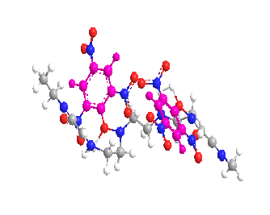  
SEM IMAGE OF POLYMERIC AZO-AZINE GEL